*­*

|  |  |
| --- | --- |
| *Pacific Gas and Electric Company* | |
| Release 8 Installation Guide | |
|  |  |
|  |  |
| Project | ED AM/GIS |
|  |  |
| Prepared by | Ashish Narasimham |
| Date | 6/23/2014 |
| Version | 1.4 |
| Version Type | Final |

|  |  |  |  |
| --- | --- | --- | --- |
| Revision History | | | |
| Document # | Date | Author | Summary of Changes |
| 1.0 | 1/7/14 | Ashish Narasimham | Initial Document Creation |
| 1.1 | 1/13/14 | Ashish Narasimham | Revision based on Don’s comments after first runthrough |
| 1.2 | 1/15/14 | Ashish Narasimham | Revision based on Don’s comments after additional steps and runthrough |
| 1.3 | 3/6/14 | Ashish Narasimham |  |
| 1.4 | 5/22/14 | Roger Carribine | Removed OOTB UFM steps now being applied in a different release |

# Introduction

## Purpose

This document is intended to detail the implementation and configuration steps required to implement Release 8 Installation Guide. This document describes the various configuration aspects required to complete any manual or automatic patch associated with this release. Each section in this document contains the steps required to patch the system in production.

## Terms Used

|  |  |
| --- | --- |
| OOTB | Out of the box. Unmodified from the commercial version. |
| TFS | Team Foundation Server |

## External Documents

Referenced are any external configuration documents or exports. These are documents that contain more detailed information about configuring a system or documents that can be loaded into an application to perform the configuration detailed in this document.

1. [Folder](\\\\sfetgis-nas01\\sfgispoc_data\\ApplicationDevelopment\\IBM_Delivery\\ReleaseInstructions\\Data Model 8.0, UFM and stored display) containing all necessary files
   1. MDB with 50 scale annotation feature classes, “
   2. New font file to install, “PG&E_ED_Distribution_Map1.ttf”
   3. Connectivity rules for geometric networks, “GeometricNetworks-V8.xml”
   4. Views script, “PGE_CREATE_VIEWS.sql”

## List Of Fixes

Below is the list of change requests detailing all fixes for the data model for this release:

|  |  |  |
| --- | --- | --- |
| **Item Number** | | **Title** |
| [11098](http://edappgistfsprd1:8080/tfs/ElectricDistCollection/EDAMGIS/_workItems#_a=edit&id=11098) | | UFM Pilot - Data Model 8.0 changes |
| [11285](http://edappgistfsprd1:8080/tfs/ElectricDistCollection/EDAMGIS/_workItems#_a=edit&id=11285) | Create Network Protector FeatureClass |
| [11372](http://edappgistfsprd1:8080/tfs/ElectricDistCollection/EDAMGIS/_workItems#_a=edit&id=11372) | SFO & OAK UG New Symbol Needs |
| [10270](http://edappgistfsprd1:8080/tfs/ElectricDistCollection/EDAMGIS/_workItems#_a=edit&id=10270) | Modify SUBFuseAnno feature |
| [10298](http://edappgistfsprd1:8080/tfs/ElectricDistCollection/EDAMGIS/_workItems#_a=edit&id=10298) | SUBLink modifications |
| [11478](http://edappgistfsprd1:8080/tfs/ElectricDistCollection/EDAMGIS/_workItems#_a=edit&id=10298) | TransformerUnit Table, Add SAP Fields |
| [11129](http://edappgistfsprd1:8080/tfs/ElectricDistCollection/EDAMGIS/_workItems#_a=edit&id=11129) | Add "FACILITYDIAGRAM" field to EDGIS.SubsurfaceStructure |
| [11141](http://edappgistfsprd1:8080/tfs/ElectricDistCollection/EDAMGIS/_workItems#_a=edit&id=11141) | New valid values for Conductor Insulation -UG Domain |
| [11175](http://edappgistfsprd1:8080/tfs/ElectricDistCollection/EDAMGIS/_workItems#_a=edit&id=11175) | New Domain Values for ULS Material - Duct Bank |
| [11283](http://edappgistfsprd1:8080/tfs/ElectricDistCollection/EDAMGIS/_workItems#_a=edit&id=11283) | Add NetworkGroupName field to circuitsource table. |
| [11284](http://edappgistfsprd1:8080/tfs/ElectricDistCollection/EDAMGIS/_workItems#_a=edit&id=11284) | Alter Transformer for network transformers |
| [11287](http://edappgistfsprd1:8080/tfs/ElectricDistCollection/EDAMGIS/_workItems#_a=edit&id=11287) | Add Ground Switch subtype to switch and field of Spot Group Name |
| [11377](http://edappgistfsprd1:8080/tfs/ElectricDistCollection/EDAMGIS/_workItems#_a=edit&id=11377) | ConductorRating Domain Modifications |
| [11402](http://edappgistfsprd1:8080/tfs/ElectricDistCollection/EDAMGIS/_workItems#_a=edit&id=11402) | Create New Domain - "Duct Use Condition" |
| [11396](http://edappgistfsprd1:8080/tfs/ElectricDistCollection/EDAMGIS/_workItems#_a=edit&id=11396) | Add New Fields to Duct Feature |
| [11397](http://edappgistfsprd1:8080/tfs/ElectricDistCollection/EDAMGIS/_workItems#_a=edit&id=11397) | Set DUCT Feature Attribute Default Values |
| [11405](http://edappgistfsprd1:8080/tfs/ElectricDistCollection/EDAMGIS/_workItems#_a=edit&id=11405) | Add CircuitName Attribute to OH and UG Conductor Features |
| [11409](http://edappgistfsprd1:8080/tfs/ElectricDistCollection/EDAMGIS/_workItems#_a=edit&id=11409) | Add StreetlightLoopNumber Attribute to Conductor Features |
| [11431](http://edappgistfsprd1:8080/tfs/ElectricDistCollection/EDAMGIS/_workItems#_a=edit&id=11431) | Domain "Device Group Type - Subsurface" Add Domain Value |
| [11432](http://edappgistfsprd1:8080/tfs/ElectricDistCollection/EDAMGIS/_workItems#_a=edit&id=11432) | Set DeviceGroup Feature Attribute Default Value |
| [11433](http://edappgistfsprd1:8080/tfs/ElectricDistCollection/EDAMGIS/_workItems#_a=edit&id=11433) | Add New Attributes to SubsurfaceStructure Feature |
| [11462](http://edappgistfsprd1:8080/tfs/ElectricDistCollection/EDAMGIS/_workItems#_a=edit&id=11462) | Domain "Street Light Lumens" Add New Values |
| [11477](http://edappgistfsprd1:8080/tfs/ElectricDistCollection/EDAMGIS/_workItems#_a=edit&id=11477) | TransformerDevice Table, Add SAP Fields |
| [11545](http://edappgistfsprd1:8080/tfs/ElectricDistCollection/EDAMGIS/_workItems#_a=edit&id=11545) | Streetlight Add New Fields and Domain for San Francisco |
| [11187](http://edappgistfsprd1:8080/tfs/ElectricDistCollection/EDAMGIS/_workItems#_a=edit&id=11187) | DCDEVICE Feeature Class for SF and Oakland conversion |
| [11608](http://edappgistfsprd1:8080/tfs/ElectricDistCollection/EDAMGIS/_workItems#_a=edit&id=11608) | Add Installation and Status fields to DCDevice |
| [11376](http://edappgistfsprd1:8080/tfs/ElectricDistCollection/EDAMGIS/_workItems#_a=edit&id=11376) | Set DCConductorInfo Table Attribute Default Values |
| [11383](http://edappgistfsprd1:8080/tfs/ElectricDistCollection/EDAMGIS/_workItems#_a=edit&id=11383) | Set DCRectifier Attribute Value Default |
| [11455](http://edappgistfsprd1:8080/tfs/ElectricDistCollection/EDAMGIS/_workItems#_a=edit&id=11455) | Add New Field to DCRectifier Feature |
| [11456](http://edappgistfsprd1:8080/tfs/ElectricDistCollection/EDAMGIS/_workItems#_a=edit&id=11456) | Add New Annotation SubType/ClassId to DCRectifierAnno |
| [11659](http://edappgistfsprd1:8080/tfs/ElectricDistCollection/EDAMGIS/_workItems#_a=edit&id=11659) | 1:600 (50ft) Scale Annotation Classes |
| [11660](http://edappgistfsprd1:8080/tfs/ElectricDistCollection/EDAMGIS/_workItems#_a=edit&id=11660) | Add New DCConductor Anno Class |
| [11621](http://edappgistfsprd1:8080/tfs/ElectricDistCollection/EDAMGIS/_workItems#_a=edit&id=11621) | Add fields and Relationship to NetworkProtector feature class |
| [11673](http://edappgistfsprd1:8080/tfs/ElectricDistCollection/EDAMGIS/_workItems#_a=edit&id=11673) | Remove NetworkProtector_DeviceGroup Relationship |
| [11625](http://edappgistfsprd1:8080/tfs/ElectricDistCollection/EDAMGIS/_workItems#_a=edit&id=11625) | Add fields and Relationship to Switch feature class |
| [11665](http://edappgistfsprd1:8080/tfs/ElectricDistCollection/EDAMGIS/_workItems#_a=edit&id=11665) | Add values to Conductor Insulation - UG Domain |
| 11784 | FaultIndicator AU Cleanup |
| 11611 | Create Proposed Annotation Views |

## Summary of Steps to Complete Patch

These are the high-level steps to complete the installation and configuration of the data model patch. Use this table as a guide for completing the installation. Links are provided that can lead either within the document for detailed explanations or to external sites such as Sharepoint.

Table of Contents

1 Introduction 3

1.1 Purpose 3

1.2 Terms Used 3

1.3 External Documents 3

1.4 List Of Fixes 4

1.5 Summary of Steps to Complete Patch 6

2 Open a Database Connection in ArcCatalog 9

3 Create Network Protector FeatureClass 10

3.1 Delete the NetworkProtector object class 10

3.2 Create Network Protector 11

3.3 Network Protector ArcFM Settings 12

3.4 Create Network Protector Anno 40

4 SUBFuseAnno Annotation Expression Change 49

5 SUBLink modifications 52

6 TransformerUnit Table, Add SAP Fields 67

7 Add "FACILITYDIAGRAM" field to EDGIS.SubsurfaceStructure 68

8 New valid values for Conductor Insulation -UG Domain 69

9 New Domain Values for ULS Material - Duct Bank 70

10 Add NetworkGroupName field to circuitsource table. 71

11 Alter Transformer for network transformers 72

12 Add Ground Switch subtype to switch and field of Spot Group Name 74

13 ConductorRating Domain Modifications 76

14 Create New Domain - "Duct Use Condition" 77

15 Add New Fields to Duct Feature 78

16 Set DUCT Feature Attribute Default Values 79

17 Add CircuitName Attribute to OH and UG Conductor Features 80

18 Add StreetlightLoopNumber Attribute to Conductor Features 82

19 Domain "Device Group Type - Subsurface" Add Domain Value 83

20 Add New Attributes to SubsurfaceStructure Feature 84

21 Domain "Street Light Lumens" Add New Values 86

22 TransformerDevice Table, Add SAP Fields 87

23 Streetlight Add New Fields and Domain for San Francisco 88

24 DCDEVICE Feeature Class for SF and Oakland conversion 89

24.1 DC Rectifier 89

24.2 DC Device 91

24.3 DC Device Annotation 92

24.4 Add Installation and Status fields to DCDevice 98

24.5 DCDevice ArcFM Properties 102

25 Set DCConductorInfo Table Attribute Default Values 117

26 Set DCRectifier Attribute Value Default 121

27 Add New Field to DCRectifier Feature 125

28 Add New Annotation SubType/ClassId to DCRectifierAnno 127

29 1:600 (50ft) Scale Annotation Classes 134

30 Rebuild Geometric Networks 152

31 ArcFMify ElectricDataset 154

32 Insert GlobalIDs into all new feature classes 162

33 Assign ArcFM Properties 163

33.1 Remove Feeder Manager AUs from DC Rectifier 167

33.2 Remove Feeder Manager AUs from DC Conductor 170

33.3 Remove AUs From FaultIndicator 173

34 Create Relationships 175

34.1 Create relationship for NetworkProtector, Transformer 175

34.2 Create relationship for NetworkProtector, Controller 180

34.3 Create Relationship for Switch, Transformer 187

35 Create 50 Scale Annotation Views 192

36 Update Data Model Version Table 193

37 Known Issues 194

# Open a Database Connection in ArcCatalog

1. Open ArcCatalog.
2. Within the Catalog Tree, expand “Database Connections” and open the active connection for this process. This is the connection that is referenced in the change request associated with this document (EDGIS<DB name in the format X#Y> )

# Create Network Protector FeatureClass

## Delete the NetworkProtector object class

1. At the root level of the database in ArcCatalog locate NetworkProtector
2. Right click on NetworkProtector and click “Delete”
3. Click on “Yes”

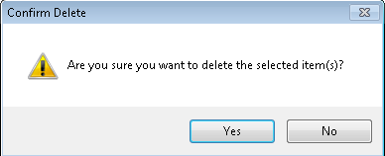

## Create Network Protector

1. Copy the personal geodatabase referenced in Section 1.3.locally.
2. Add the folder in which the PGDB is located to your Folder Connections  
   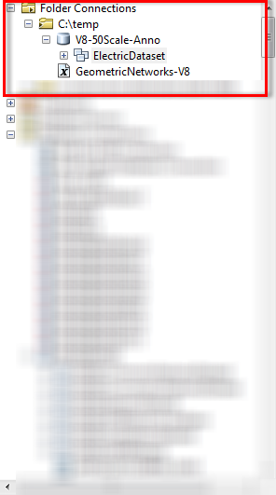
3. Drag and drop the NetworkProtector feature class into the target geodatabase in the Electric Dataset

## Network Protector ArcFM Settings

1. Right click on NetworkProtector and click “ArcFM Properties Manager”
2. Click on the “Model Names” tab and set Model Names as shown below

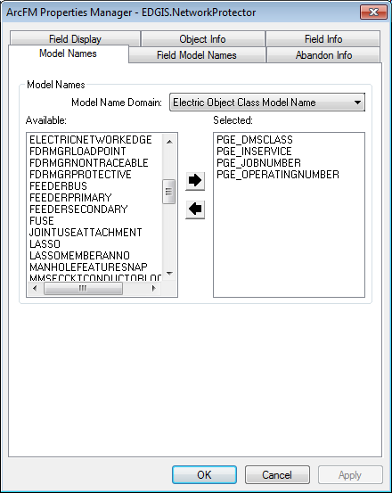

1. Click on the “Field Model Names” and set as shown below using the PGE ED Field Model Name domain from the Model Name Domain dropdown if the Model Name is prefixed with “PGE_”.

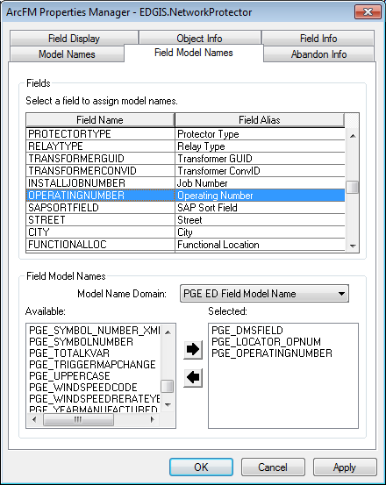

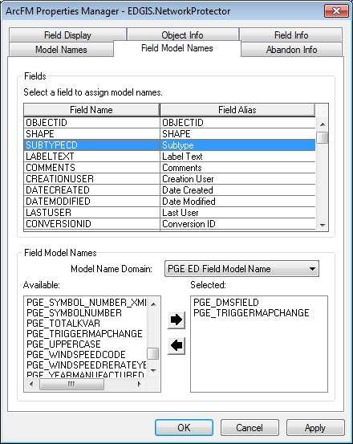

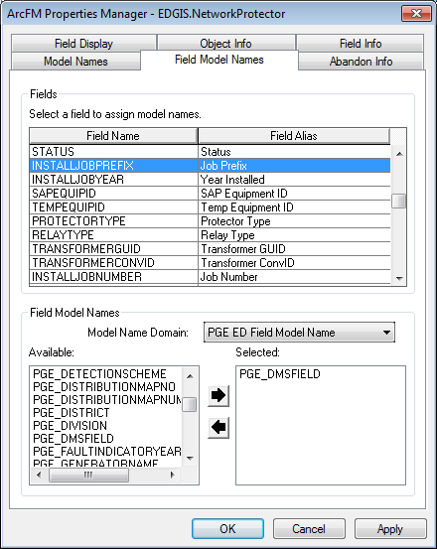

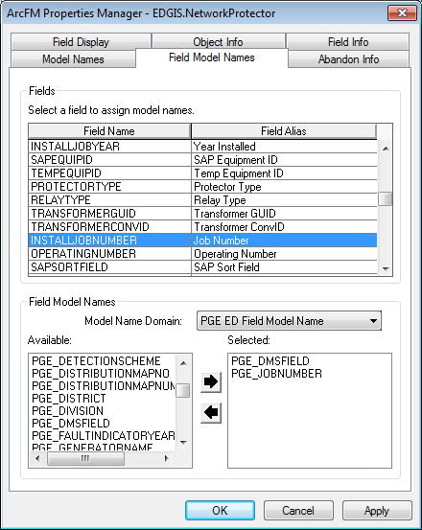

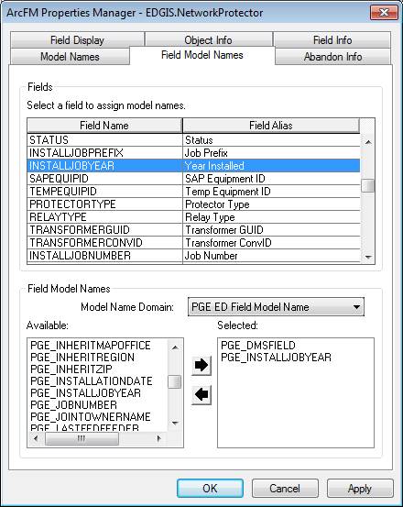

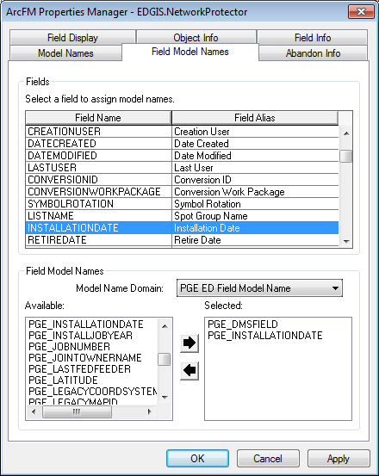

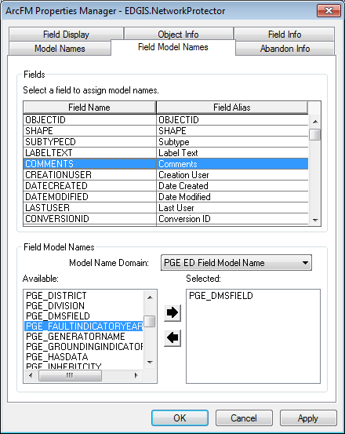

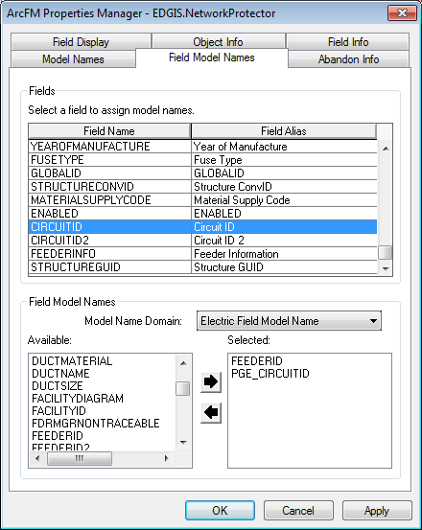

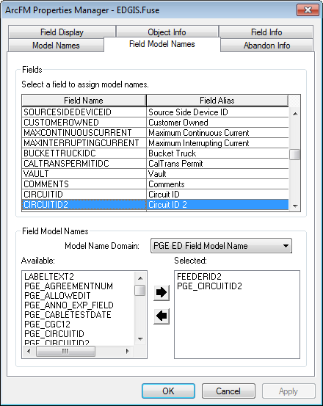

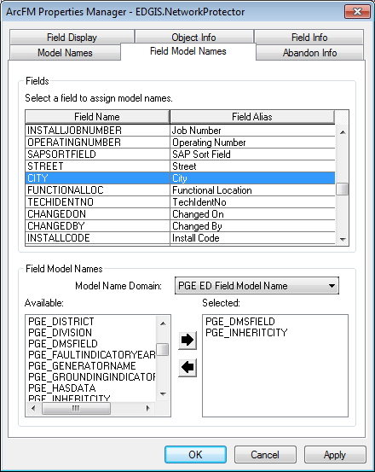

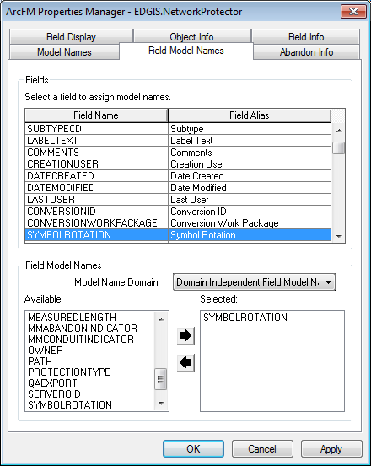

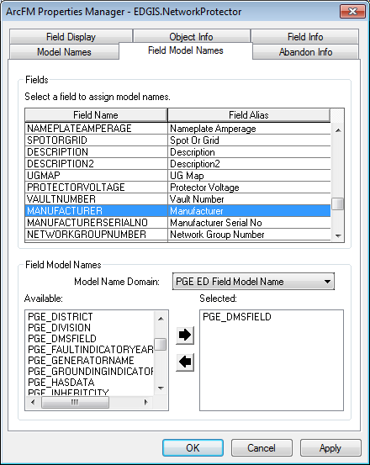

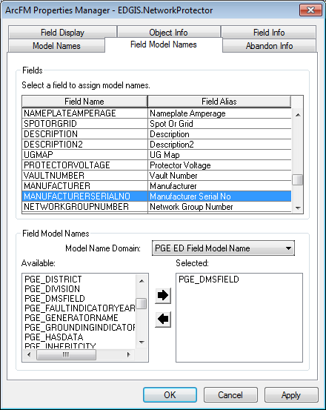

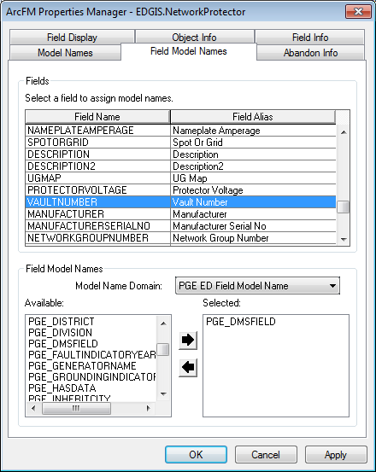

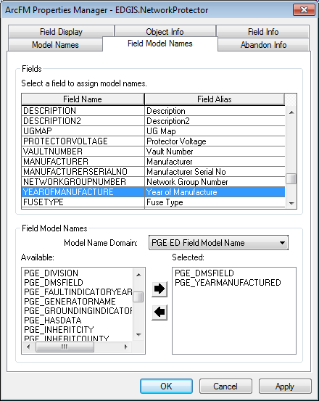

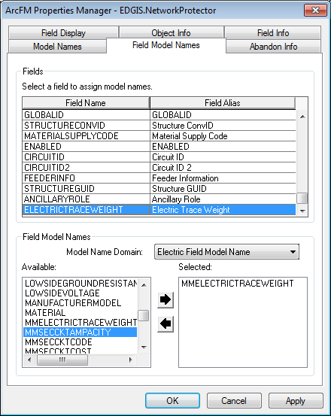

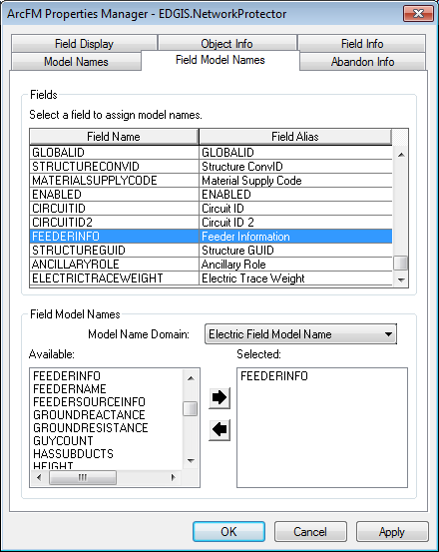

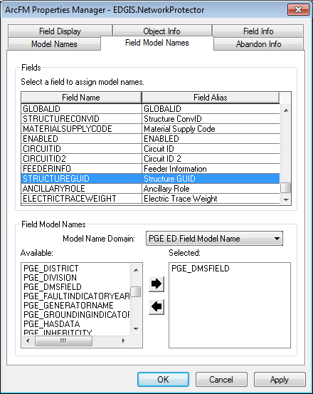

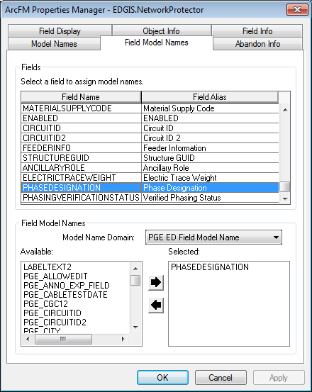

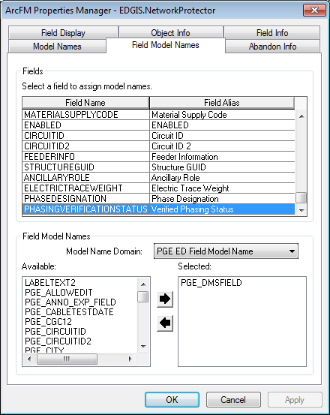

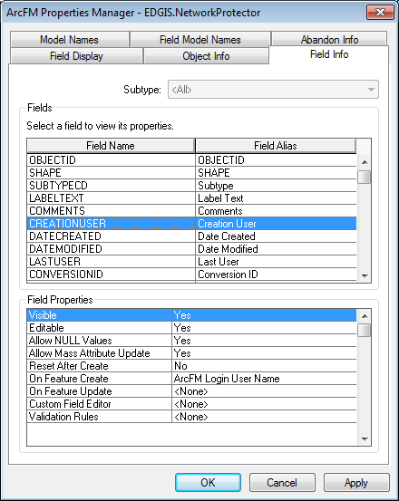

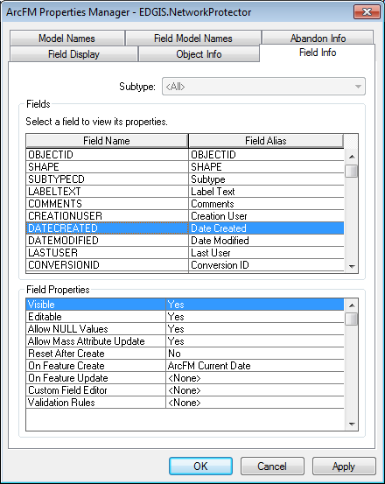

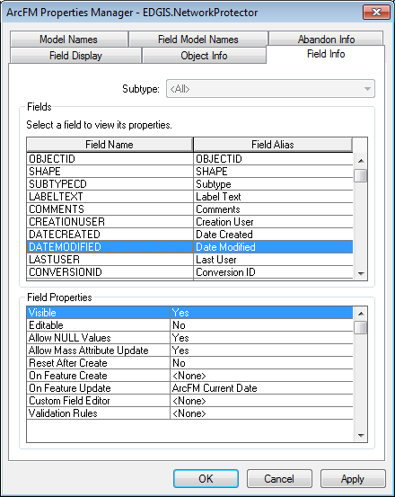

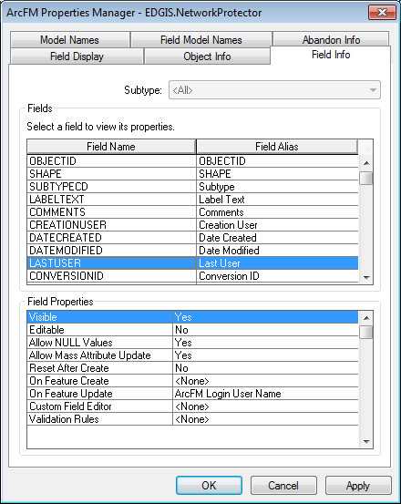

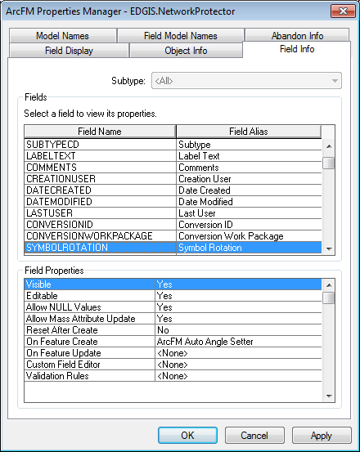

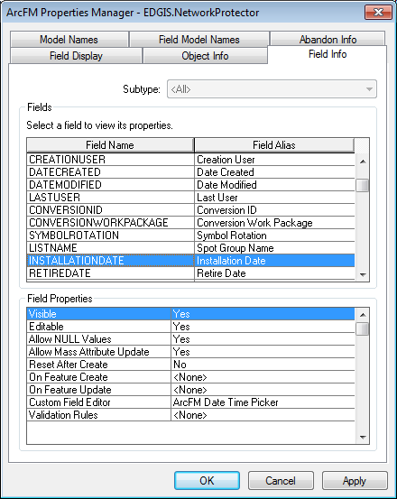

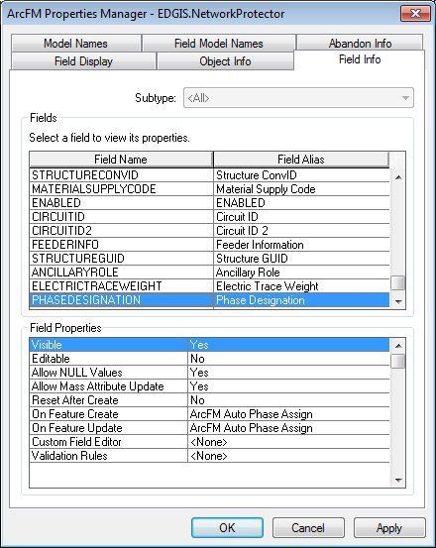

## Create Network Protector Anno

1. Right click in the content view of ArcCalalog and click “New->Feature Class..”
2. Populate as shown below and click “Next”

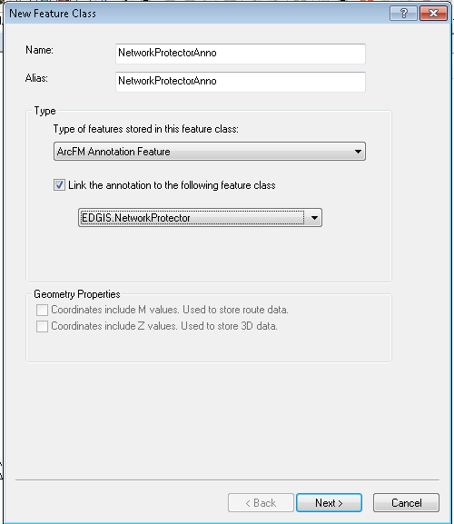

1. Populate as shown below and click “Next”

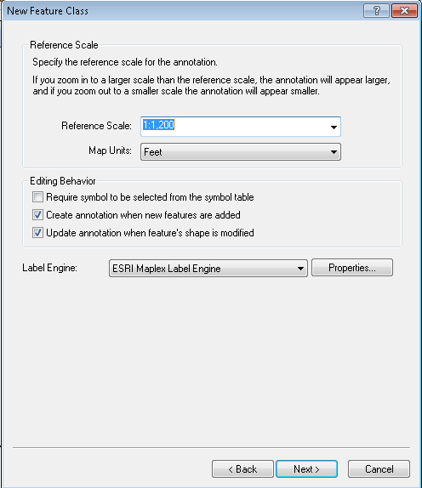

1. Populate as shown below and click “Symbol…”

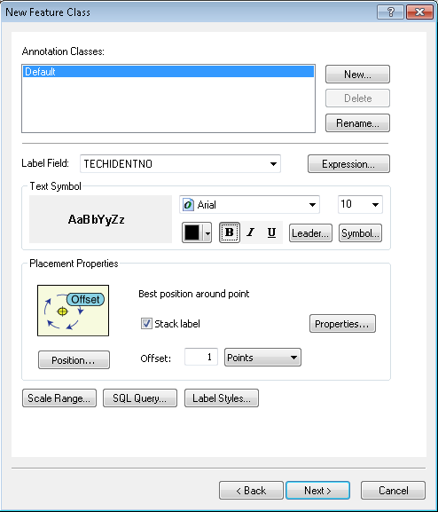

1. Change “Size” to ‘10’ and click “Edit Symbol…”

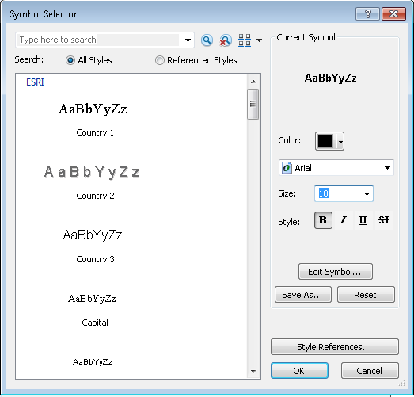

1. Populate as shown below and click “OK” on the Editor and Symbology Selector dialogs

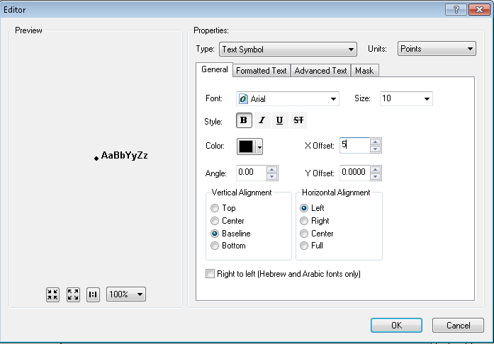

1. Click “Next” on the New Feature Class dialog

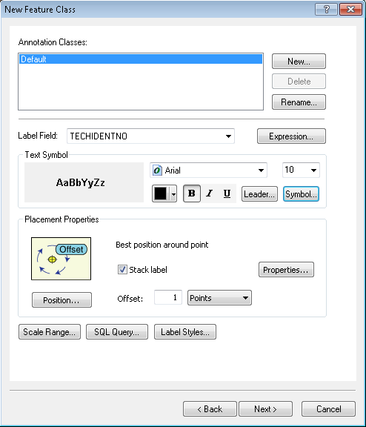

1. Click “Next”

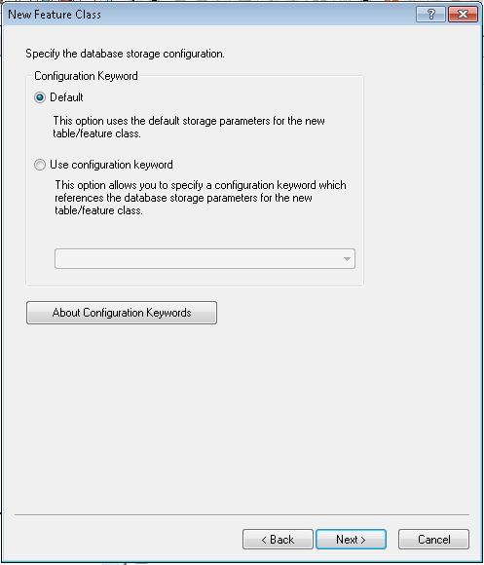

1. Click “Finish”

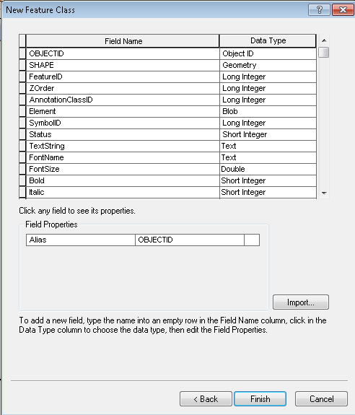

1. Locate the generic named annotation relationship

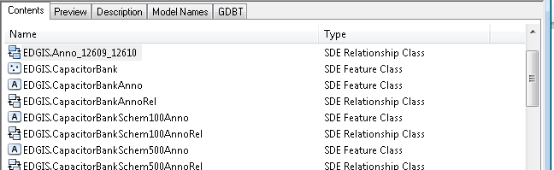

1. Right click on the generic named annotation relationship and rename as shown below

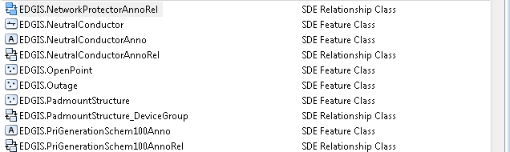

# SUBFuseAnno Annotation Expression Change

1. Right click on EDGIS.SUBFuseAnno in the EDGIS.SubstationDataset dataset and click properties
2. Click on the “Annotation Classes” tab

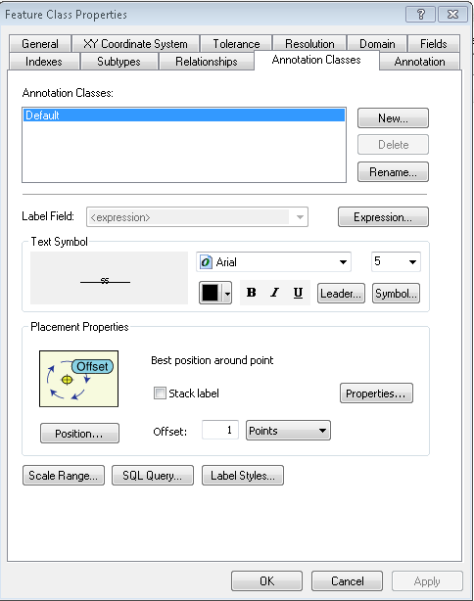

1. In the “Annotation Classes” tab click on the “Expression…” button to expose the below dialog

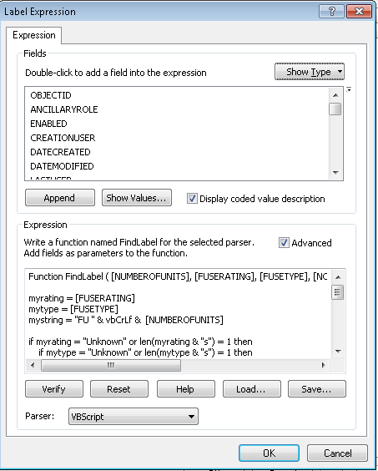

1. Select all content in the “Expression” text box, delete it,and replace with the below expression:

Function FindLabel ( [NUMBEROFUNITS], [FUSERATING], [FUSETYPE], [NORMALPOSITION_A], [NORMALPOSITION_B], [NORMALPOSITION_C])

myrating = [FUSERATING]

mytype = [FUSETYPE]

mystring = "FU " & vbCrLf & [NUMBEROFUNITS]

if myrating = "Unknown" or len(myrating & "s") = 1 then

if mytype = "Unknown" or len(mytype & "s") = 1 then

FindLabel = mystring

else

FindLabel = mystring & " - " & mytype

end if

else

if mytype = "Unknown" or len(mytype & "s") = 1 then

FindLabel = mystring & " - " & myrating

else

FindLabel = mystring & " - " & myrating & " " & mytype

end if

end if

if [NORMALPOSITION_A] = "Open" OR [NORMALPOSITION_B] = "Open" OR [NORMALPOSITION_C] = "Open" then

FindLabel = "<CLR green='125'> " & FindLabel & " </CLR>"

else

FindLabel = FindLabel

end if

End Function

# SUBLink modifications

1. In ArcCatalog, click on the EDGIS.SubstationDataset in the “Catalog Tree” panel.
2. Right click in the “Contents” panel (panel on the right) and click “New->Feature Class”
3. Populate as shown below and click “Next”

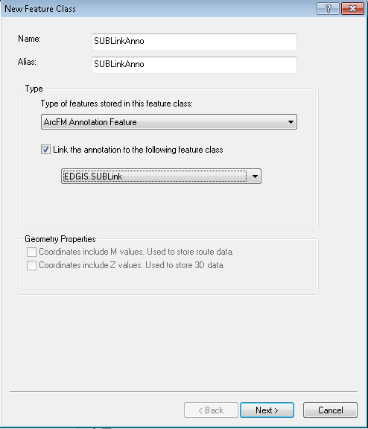

1. Populate as shown below and click “Next”

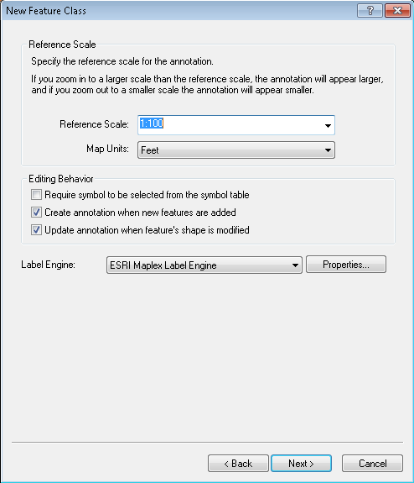

1. Click “Rename” and change from ‘Default’ to ‘Operating-1 Line’, change size to 5, uncheck “Stack Label” and click on “Expression…”

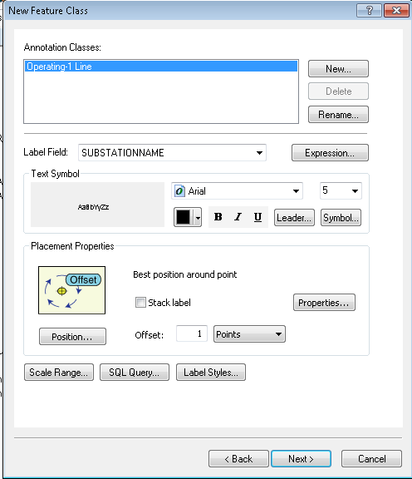

1. Populate as shown below with the below expression and click “OK”

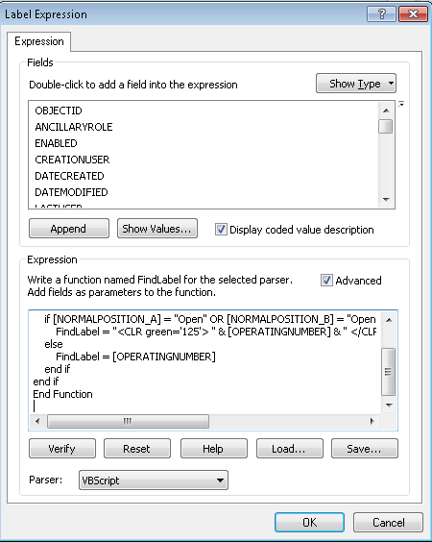

Function FindLabel ( [OPERATINGNUMBER], [OPERATINGNUMBER2], [NORMALPOSITION_A], [NORMALPOSITION_B], [NORMALPOSITION_C] )

if isnull([OPERATINGNUMBER2]) and not isnull([OPERATINGNUMBER]) then

if [NORMALPOSITION_A] = "Open" OR [NORMALPOSITION_B] = "Open" OR [NORMALPOSITION_C] = "Open" then

FindLabel = "<CLR green='125'> " & [OPERATINGNUMBER] & " </CLR>"

else

FindLabel = [OPERATINGNUMBER]

end if

end if

End Function

1. Click “New…”, enter the name as shown below and click “OK”

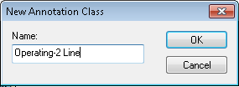

1. Click “Expression…” and replace the expression with the below expression

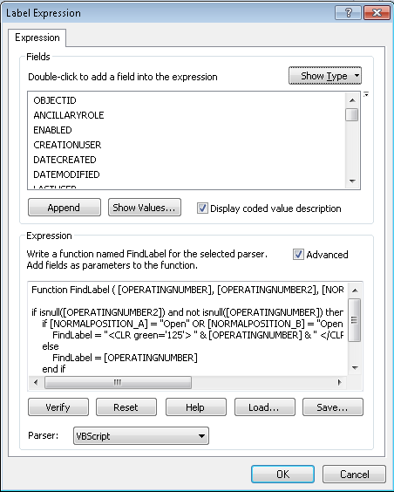

Function FindLabel ( [OPERATINGNUMBER], [OPERATINGNUMBER2], [NORMALPOSITION_A], [NORMALPOSITION_B], [NORMALPOSITION_C] )

if not isnull([OPERATINGNUMBER2]) and not isnull([OPERATINGNUMBER]) then

if [NORMALPOSITION_A] = "Open" OR [NORMALPOSITION_B] = "Open" OR [NORMALPOSITION_C] = "Open" then

FindLabel = "<CLR green='125'> " & [OPERATINGNUMBER] & vbcrlf & [OPERATINGNUMBER2] & " </CLR>"

else

FindLabel = [OPERATINGNUMBER] & vbcrlf & [OPERATINGNUMBER2]

end if

end if

End Function

1. With Operating-2 Line still highlighted click on “Symbol..”
2. Click on “Edit Symbol…”

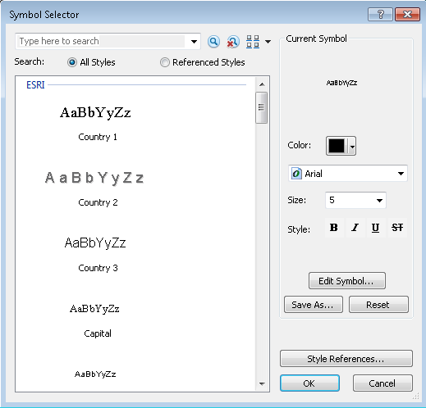

1. Click on “Advanced Text” tab, check the “Text background” checkbox and click “Properties…”

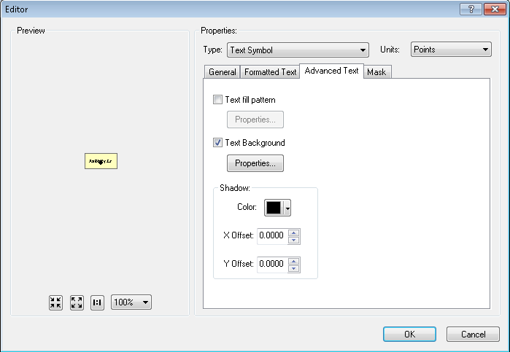

1. Change “Type” to ‘Marker Text Background’ and click “Symbol…”

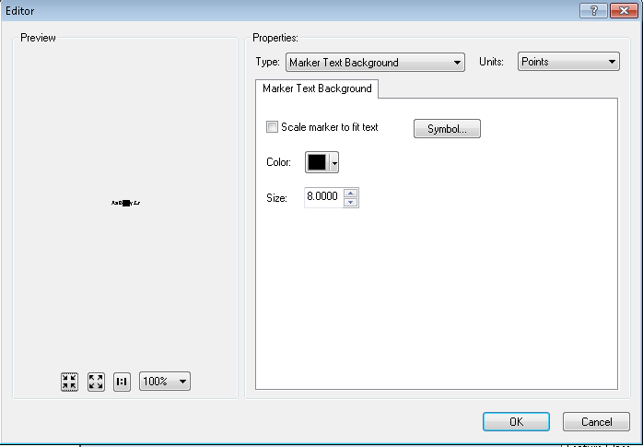

1. Click “Edit Symbol”

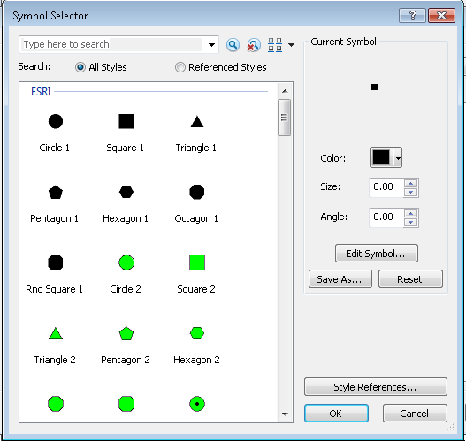

1. Set properties as shown below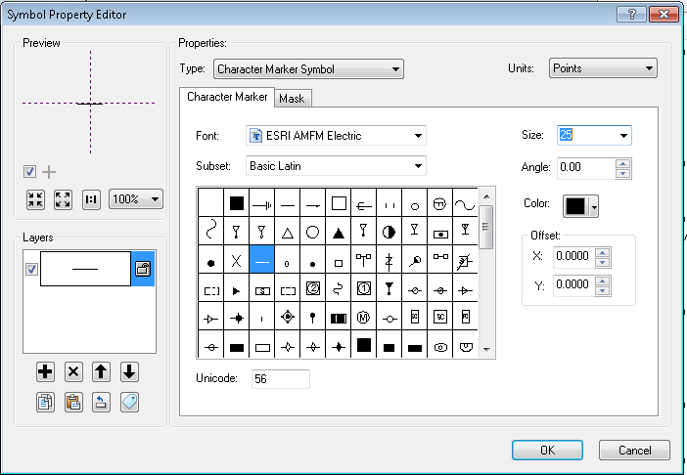
2. Click “OK” on all dialogs until you are back to the below dialog and click “Next”

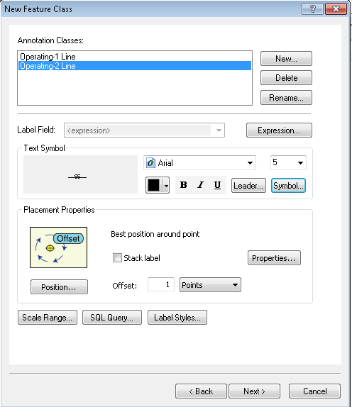

1. Click “Next”

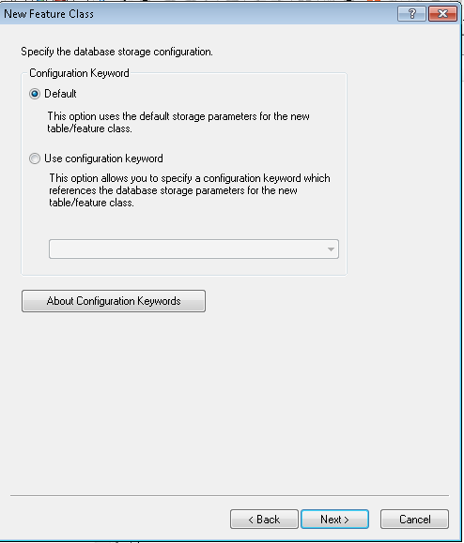

1. Click “Finish’

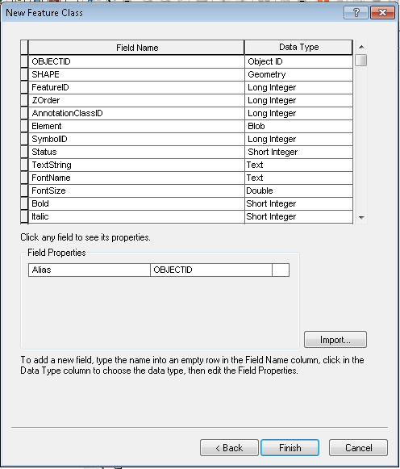

1. Locate the feature class to annotation relationship

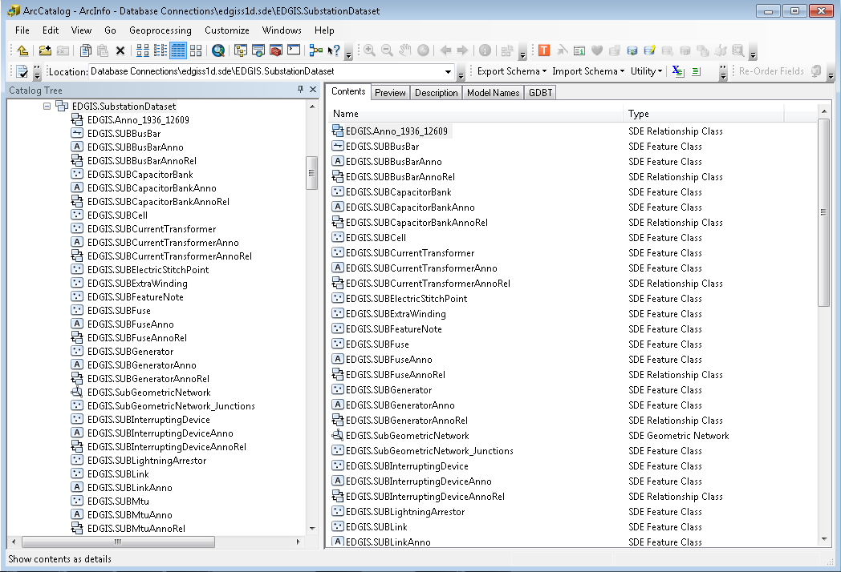

1. Right click and click “Rename” Change the name to ‘EDGIS.SUBLinkAnnoRel’

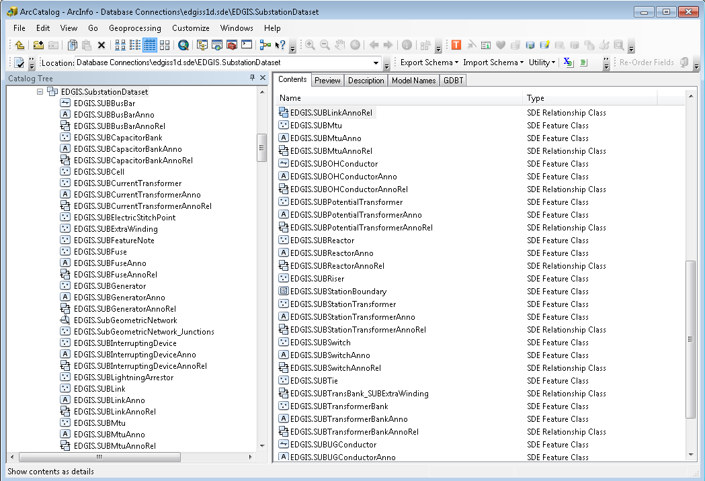

# TransformerUnit Table, Add SAP Fields

1. Open The TransformerUnit table’s Properties window in ArcCatalog at the root level.
2. Scroll to the bottom of the fields tab and add the following fields. Note that Default and Domain should be left blank since they are not specified.

|  |  |  |  |
| --- | --- | --- | --- |
| **Name** | **Alias** | **Nullable** | **Type** |
| POSITIONDESCRIPTION | Position Description | Allow NULLS | Text(50) |
| SAPSORTFIELD | SAP Sort Field | Allow NULLS | Text(50) |
| LISTNAME | Spot Group Name | Allow NULLS | Text(50) |

1. End result:  
   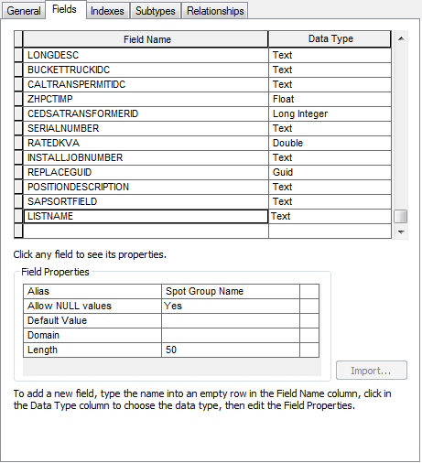

# Add "FACILITYDIAGRAM" field to EDGIS.SubsurfaceStructure

1. Open the ElectricDataset.
2. Double click SubsurfaceStructure and scroll to the bottom of the fields tab.
3. Add the following fields with the following properties to the bottom of the list:

|  |  |  |  |  |
| --- | --- | --- | --- | --- |
| **Name** | **Alias** | **Nullable** | **Type** | **Domain** |
| FACILITYDIAGRAM | Facility Diagram | Allow NULLS | Long Integer(10) | Yes No Numeric |

1. End result:  
   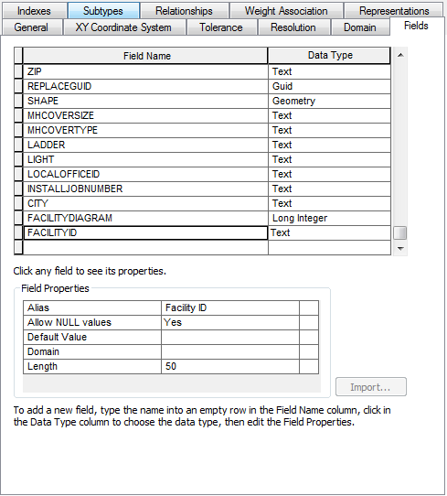

# New valid values for Conductor Insulation -UG Domain

1. Right click the database connection in ArcCatalog and select Properties.
2. In the Domains tab, scroll to the Conductor Insulation – UG domain and select it.
3. Scroll to the bottom of the Coded Values list.
4. Add the following codes and values to the list:
   1. FD – Flat Duplex
   2. RSP – Round Simplex Plastic
   3. XLA – XLA
   4. XLT – XLT
5. End result:  
   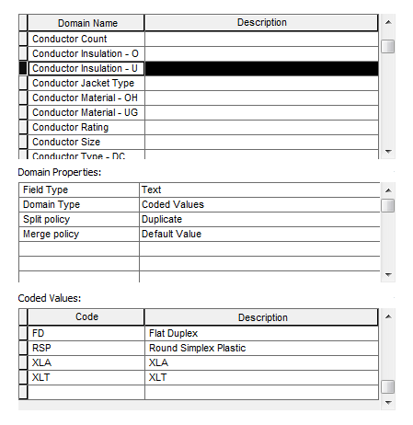

# New Domain Values for ULS Material - Duct Bank

1. Right click the database connection in ArcCatalog and click Properties.
2. In the Domains tab, scroll to the ULS Material – Duct Bank domain.
3. Scroll down to the bottom of the Coded Values list and enter the following new values and descriptions:
   1. Code = T Description = Tile
   2. Code = SS Description = Soap Stone
   3. Code = C Description = Concrete
4. End result:  
   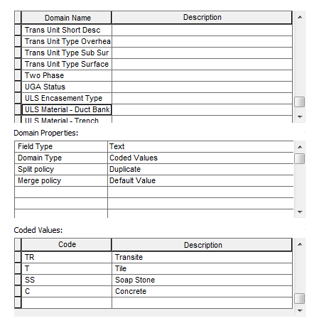

# Add NetworkGroupName field to circuitsource table.

1. At the root level, double click the CircuitSource table.
2. In the fields tab, scroll to the bottom of the list and add a new field with the following properties:
   1. Table: CircuitSource
   2. field: **NETWORKGROUPNAME**
   3. Alias: Network Group Name
   4. Type: Text
   5. Length: 15
3. End result:  
    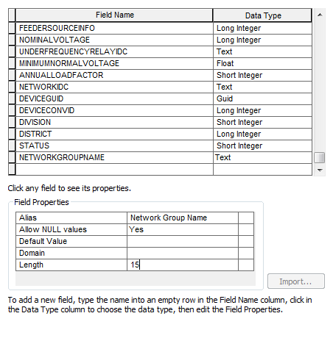

# Alter Transformer for network transformers

1. In the ElectricDataset, double click Transformer and select the Subtypes tab.
2. Highlight 5 – Network Subsurface. Rename the subtype to “Network”.
3. Highlight 6 – Network Padmount. Press delete on your keyboard.
4. Highlight the “5” row and in the Default Values list below, scroll to the SPOTIDC field.
5. Change the default to “Y”.
6. Result:

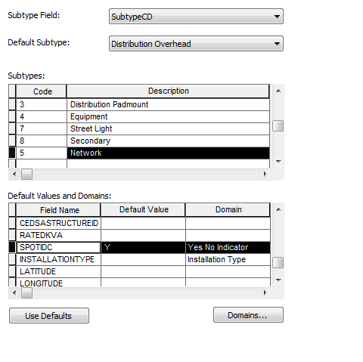

1. Select the Fields tab.
2. Locate the SPOTIDC field. Change the alias of this field to “Spot Or Grid”.  
   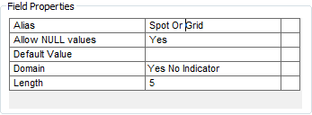
3. Add these fields to the feature class with the following properties:

|  |  |  |  |
| --- | --- | --- | --- |
| **Name** | **Alias** | **Nullable** | **Type** |
| STREET | Street | Allow NULLS | Text(50) |
| FUNCTIONALLOC | Functional Location | Allow NULLS | Text(50) |
| SUPERORDEQUIP | Super Order Equipment | Allow NULLS | Text(50) |
| TECHIDENTNO | Tech Identity No | Allow NULLS | Text(50) |
| CHANGEDON | Changed On | Allow NULLS | DATE |
| CHANGEDBY | Changed By | Allow NULLS | Text(50) |
| INSULATINGFLUIDTYPE | Insulating Fluid Type | Allow NULLS | Text(50) |
| NETWORKGROUPNUMBER | Network Group Number | Allow NULLS | Text(50) |
| VAULTLOCATION | Vault Location | Allow NULLS | Text(50) |
| SORTINGORDER | Sorting Order | Allow NULLS | Text(50) |
| SPOTWITH | Spot With | Allow NULLS | Text(50) |
| INSTRUCTIONS | Instructions | Allow NULLS | Text(50) |
| LISTNAME | Spot Group Name | Allow NULLS | Text(50) |

# Add Ground Switch subtype to switch and field of Spot Group Name

1. In the ElectricDataset, double click the Switch feature class and select the Subtypes tab.
2. Scroll to the bottom of the list of Subtypes and add a new subtype, “7” – “Ground Switch”  
   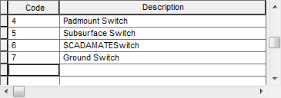
3. In the Fields tab, scroll to the bottom of the fields list and add new fields with the following properties:

|  |  |  |  |
| --- | --- | --- | --- |
| **Name** | **Alias** | **Nullable** | **Type** |
| SPOTORGRID | Spot Or Grid | Allow NULLS | Text(50) |
| LISTNAME | Spot Group Name | Allow NULLS | Text(50) |
| TRANSFORMERGUID | Transformer GUID | Allow NULLS | GUID |
| TRANSFORMERCONVID | Transformer ConvID | Allow NULLS | Long Integer(10) |

1. Result:  
   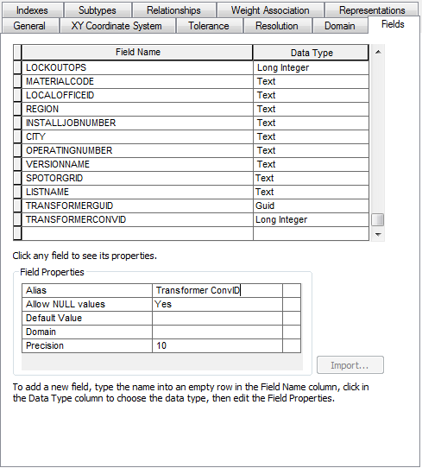
2. Set the following Defaults for the following subtypes in the Subtypes tab for the SPOTORGRID field:
   1. 1 Overhead Disconnect = n
   2. 2 Overhead Switch =n
   3. 3 Underground Disconnect = n
   4. 4 Padmount Switch = n
   5. 5 Subsurface Switch = n
   6. 6 SCADAMATESwitch = n
   7. 7 Ground Switch = Y

# ConductorRating Domain Modifications

1. Right click the database connection and select Properties.
2. In the Domains tab, scroll to the “Conductor Rating” domain and select it.
3. Scroll to the bottom of the list of Coded Values and add the following new codes/values:
   1. Code = 7; Description = 250V
   2. Code = 8; Description = 500V
4. End result:  
   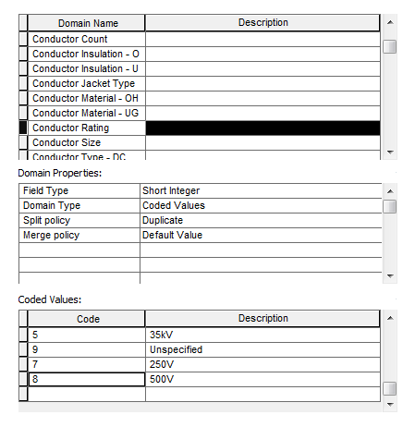

# Create New Domain - "Duct Use Condition"

1. Right click the database connection and select the Domains tab.
2. Scroll to the bottom of the Domains list and add a new domain with the following properties:
   1. Domain Properties:
      1. Field Type = Text
      2. Domain Type = Coded Values
      3. Split Policy = Default Value
      4. Merge Policy = Default Value
   2. Coded Values: Code - Description
      1. P - P
      2. DE - DE
      3. B - Blocked
      4. C - Capped
      5. F - Fiber
      6. I - Idle
      7. T - Tel
      8. V – Vent
3. End result:  
   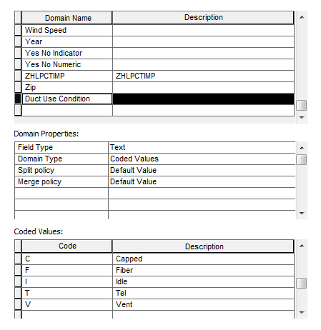

# Add New Fields to Duct Feature

1. In the UFMDataset, double click the Duct feature class.
2. Scroll to the bottom of the fields tab and add the following fields with the following properties:

|  |  |  |  |  |
| --- | --- | --- | --- | --- |
| **Name** | **Alias** | **Nullable** | **Type** | **Domain** |
| DUCTSHAPE | Duct Shape | Allow NULLS | Text(10) |  |
| BYPASS | Bypass | Allow NULLS | Text(10) | Yes No Indicator |
| CONDITION | Condition | Allow NULLS | Text(10) | Duct Use Condition |

2. End result:  
   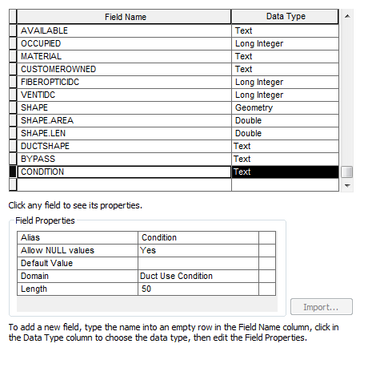

# Set DUCT Feature Attribute Default Values

1. In the UFMDataset, double click the Duct feature class.
2. In the Fields tab, set the following field default values:
   1. Set EDGIS.UFMDataset.Duct.Available default value = "1" (Available)
   2. Set EDGIS.UFMDataset.Duct.FiberOptIdc default value = "0" (No)
3. End result:  
   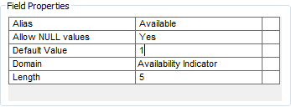  
   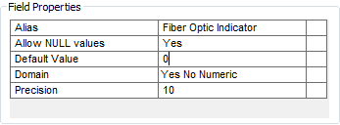

# Add CircuitName Attribute to OH and UG Conductor Features

1. In the ElectricDataset, double click the PriOHConductor feature class.
2. In the Fields tab, scroll to the bottom of the list and add the following field with the following properties:
   1. CIRCUITNAME, alias Circuit Name, Allow NULLS, Text (50)
3. End result:  
   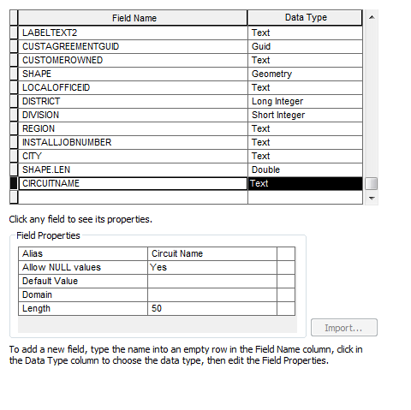
4. Select OK to apply.
5. Repeat the above steps for PriUGConductor.
6. End result:  
   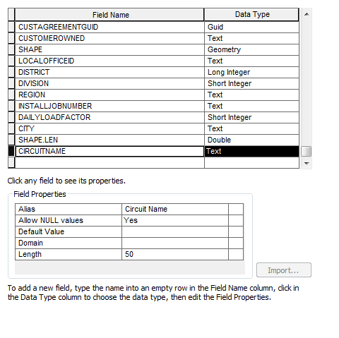

# Add StreetlightLoopNumber Attribute to Conductor Features

1. In the ElectricDataset, double click the SecOHConductor feature class.
2. In the Fields tab, scroll to the bottom of the list and add a new field with the following properties:
   1. STREETLIGHTLOOPNUMBER, alias Streetlight Loop Number, Allow NULLS, Text (50)
3. End result:  
   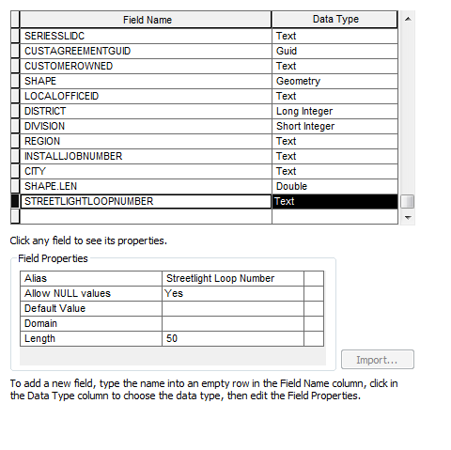
4. Press OK to apply.
5. Right click the SecOHConductor feature class and select ArcFM Properties Manager
6. In the Field Info tab, set the following properties for the following subtypes on the STREETLIGHTLOOPNUMBER:
   1. Subtype = Streetlight Overhead Conductor, Visible = Yes  
      
   2. All other subtypes, Visible = No
7. Repeat the above steps, using SecUGConductor in Step 1 and Streetlight Underground Conductor in step 6b.

# Domain "Device Group Type - Subsurface" Add Domain Value

1. Right click the database connection and select Domains.
2. Scroll to the “Device Group Type – Subsurface” domain and add the following codes/values:
   1. Coded Values: Code - Description
      1. 33 – Network
3. End result:  
   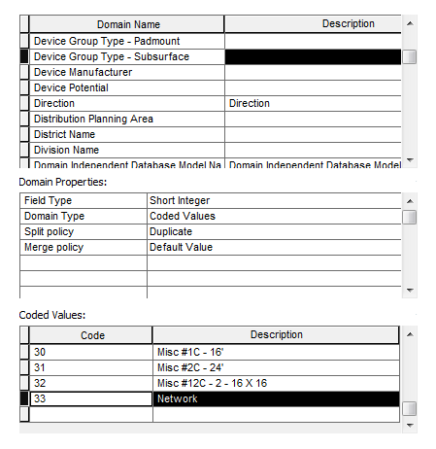

# Add New Attributes to SubsurfaceStructure Feature

1. In the ElectricDataset, double click the SubsurfaceStructure and scroll to the bottom of the Fields tab.
   1. NECKSIZE, alias "Neck Size", Allow NULLS, Short Integer
   2. NOOFVENTS, alias "Number of Vents", Allow NULLS, Short Integer
2. End result:  
   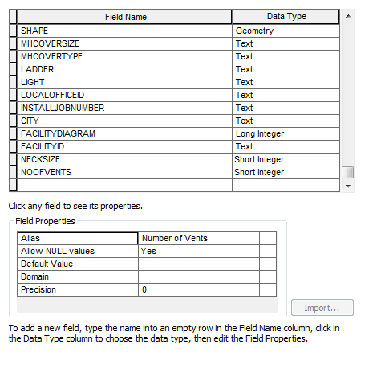
3. Select OK to apply.
4. Right click the SubsurfaceStructure and select ArcFM Properties Manager.
5. In the Field Info tab, scroll to the NOOFEVENTS field and set the following properties for the following subtypes:
   1. Subtype = Vault, Visible = Yes
   2. All other subtypes, Visible = No  
      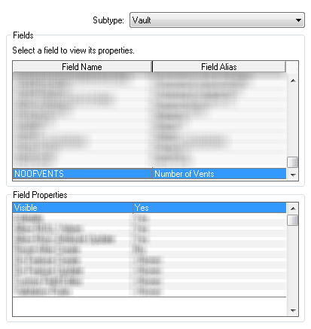

# Domain "Street Light Lumens" Add New Values

1. Right click the database connection and select the Domains tab.
2. Select the Street Light Lumens domain and add the following codes/values:
   1. 2000 - 2000L
   2. 4000 - 4000L
   3. 6000 - 6000L
3. End result:  
   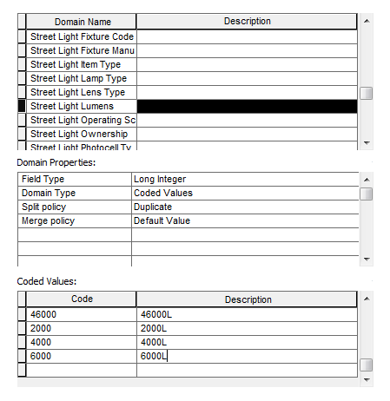

# TransformerDevice Table, Add SAP Fields

1. At the root level, double click the TransformerDevice table.
2. In the Fields tab, scroll to the bottom of the list and add the following fields with the following properties:

|  |  |  |  |
| --- | --- | --- | --- |
| **Name** | **Alias** | **Nullable** | **Type** |
| DESCRIPTION2 | Description2 | Allow NULLS | Text(50) |
| SAPSORTFIELD | SAP Sort Field | Allow NULLS | Text(50) |
| LISTNAME | Spot Group Name | Allow NULLS | Text(50) |
| FUNCTIONALLOC | Functional Location | Allow NULLS | Text(50) |
| SUPERORDEQUIP | Super Order Equipment | Allow NULLS | Text(50) |
| CHANGEDON | Changed On | Allow NULLS | Date |
| CHANGEDBY | Changed By | Allow NULLS | Text(50) |

1. End result:  
   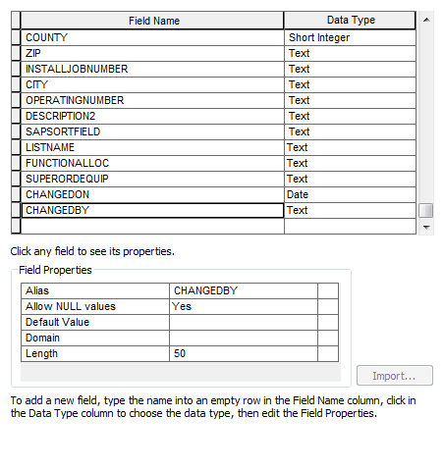

# Streetlight Add New Fields and Domain for San Francisco

1. Right click the database connection and select the Domains tab.
2. Locate the Street Light Rate Schedule domain and select it.
3. Scroll to the bottom of the Codes/Values list and add the following codes/values:
   * 1. Codes/Values: Code – Description
        1. 1 - S1
        2. 2 - S2
        3. 3 - S3
        4. 4 - S4
        5. 5 - S5
        6. 6 - S6
        7. 7 - S7
        8. 7A - S7A
        9. 8 - S8
        10. 9 - S9
        11. 11 - S11
        12. 12 - S12
        13. 13 - S13
4. Press OK to accept.

# DCDEVICE Feeature Class for SF and Oakland conversion

## DC Rectifier

Addition of Size attribute

1. Navigate to DCRectifier, right click and click Properties
2. Click on the “Fields” tab and scroll to the bottom of the field listings

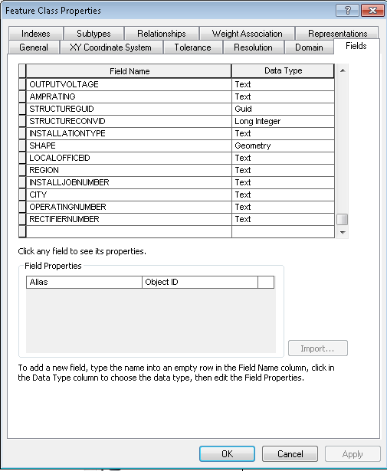

1. Add the size attribute as shown below

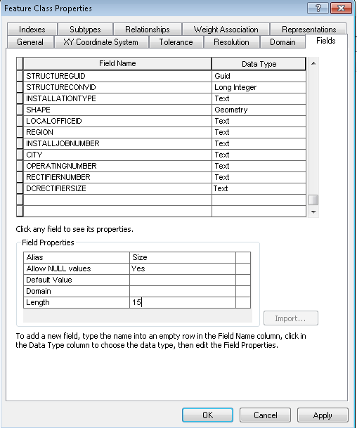

## DC Device

1. Re-open the geodatabase used to create the NetworkProtector feature class.
2. Drag and drop the DCDevice feature class into the target geodatabase in the ElectricDataset.

## DC Device Annotation

1. Within the EDGIS.ElectricDataset, Right Click in ArcCatalog’s “Contents” window and click “New->Feature Class…”
2. Set properties as shown below and click “Next”

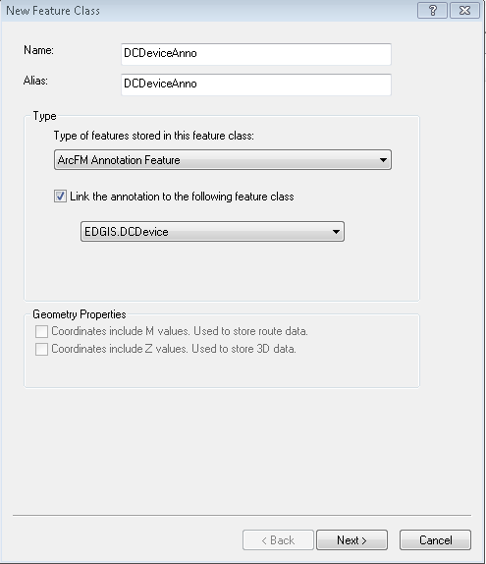

1. Enter as shown below and click “Next”

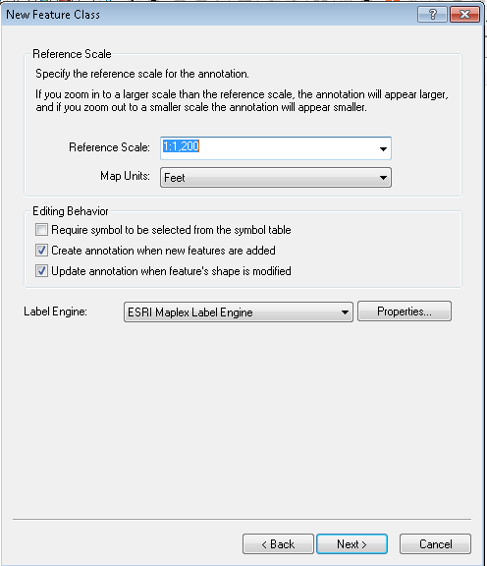

1. Enter as shown below and click “Next”

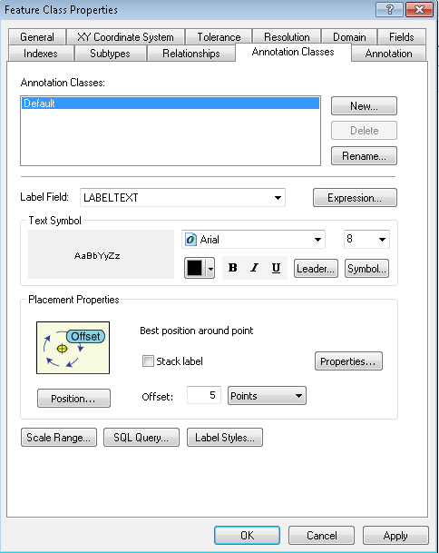

1. Click “Next”

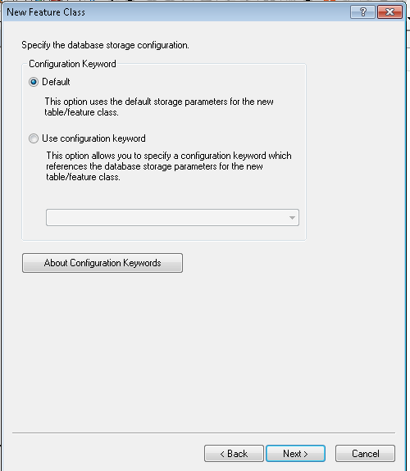

1. Click “Finish”

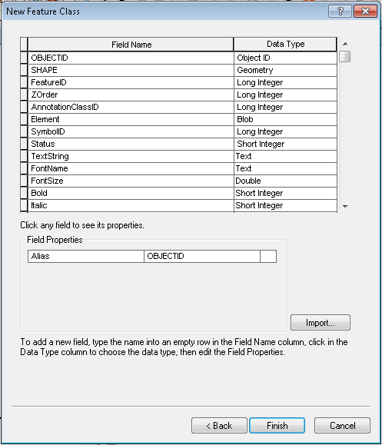

1. Locate the generic named relationship, rename by right clicking->“Rename” setting the name to ‘EDGIS.DCDeviceAnnoRel’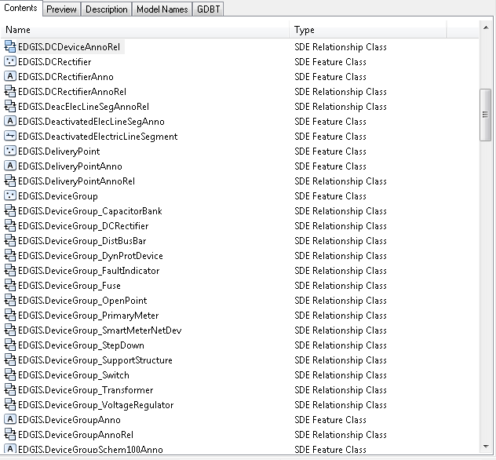

## Add Installation and Status fields to DCDevice

1. Open DCDevice properties, click on the “Fields” tab and add the fields shown below with properties matching the Field Properties section of the window. STATUS, INSTALLJOBNUMBER, INSTALLJOBPREFIX, INSTALLJOBYEAR, and INSTALLATIONDATE all should be added after this is complete.

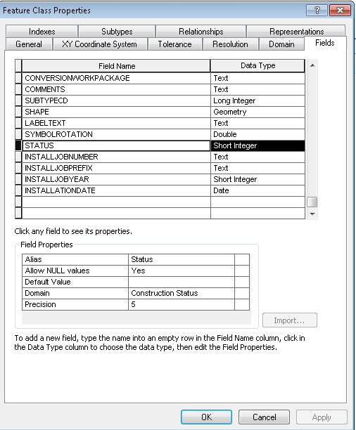

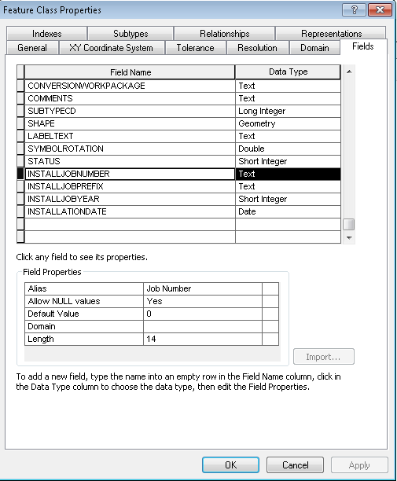

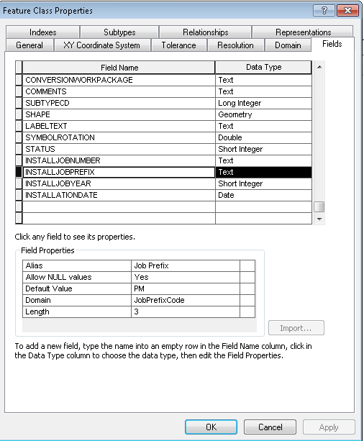

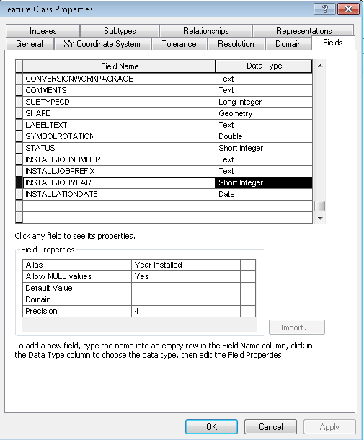

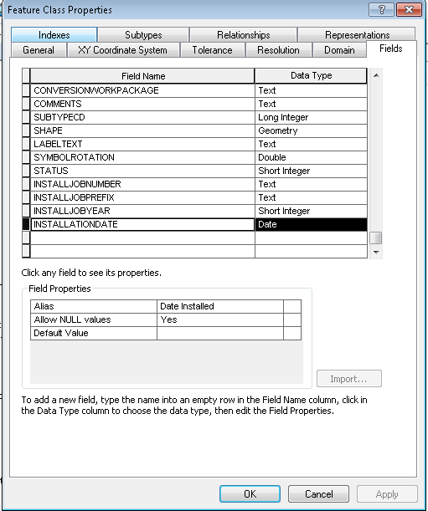

1. Click “OK”

## DCDevice ArcFM Properties

1. Open “ArcFM Properties Manager” on DCDevice and assign the below AUs and model names.
   1. Right click DCDevice and select ArcFM Properties Manager. Open the Model Names tab.
2. Assign PGE_INSERVICE and PGE_JOB NUMBER on the Model Names tab.

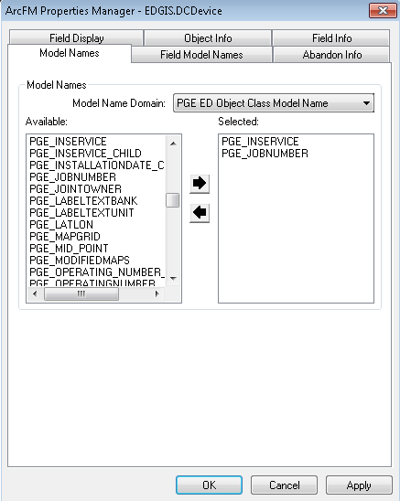

1. Assign PGE_STATUS to the STATUS field in the Field Model Names tab.

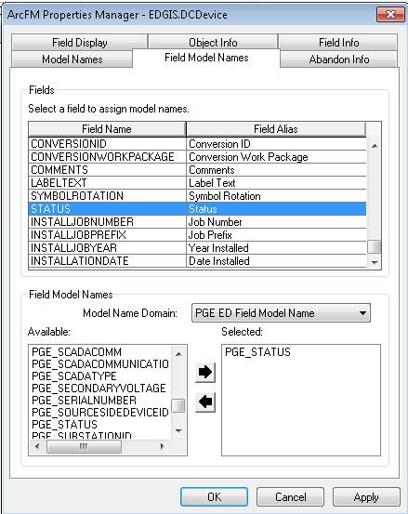

1. Assign the PGE_JOBNUMBER model name to the INSTALLJOBNUMBER field.

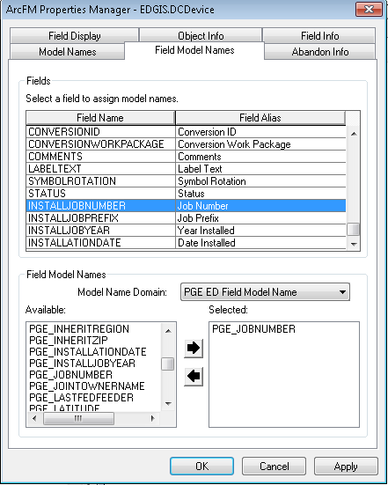

1. Assign the PGE_INSTALLJOBYEAR model name to the INSTALLJOBYEAR field.

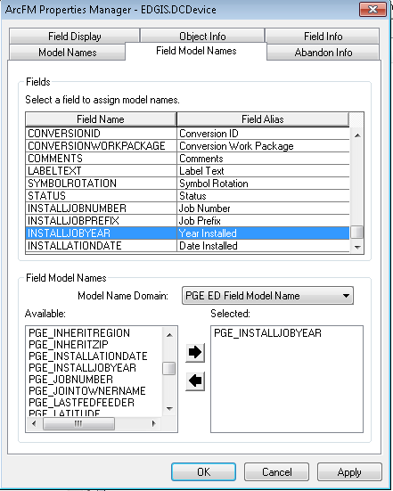

1. Assign the PGE_INSTALLATIONDATE model name to the INSTALLATIONDATE field.

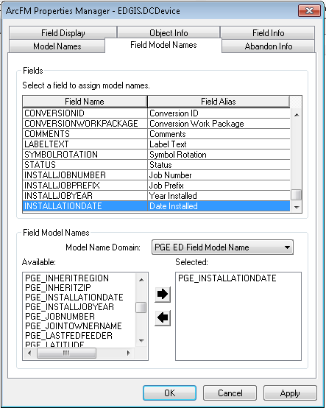

1. Assign the SYMBOLROTATION model name to the SYMBOLROTATION field. You will need to change the Model Name Domain to “Domain Independent Field Model Names”.

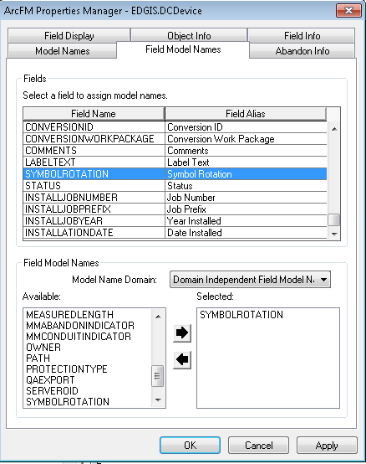

1. Click Apply.
2. Select the Object Info tab. Select the dropdown next to “On Feature Create” and select <Multiple> to bring up the following dialog:

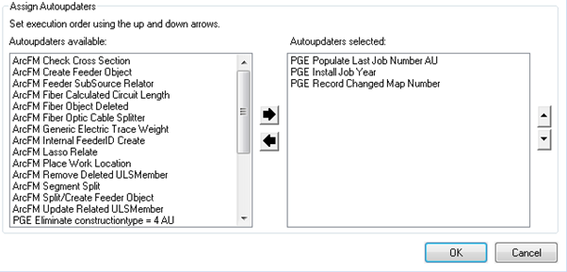

1. Assign the above autoupdaters in the order that they appear.
2. Select OK to apply.
3. Select the dropdown next to “On Feature Update” and select <Multiple>. You will see the following dialog:

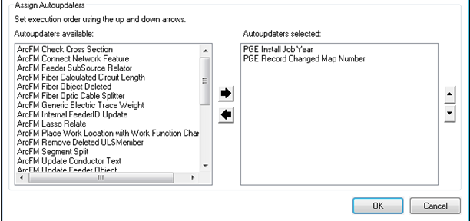

1. Assign the autoupdaters above in the order that they appear.
2. Select the dropdown next to “On Feature Delete” and select “PGE Record Changed Map Number”. 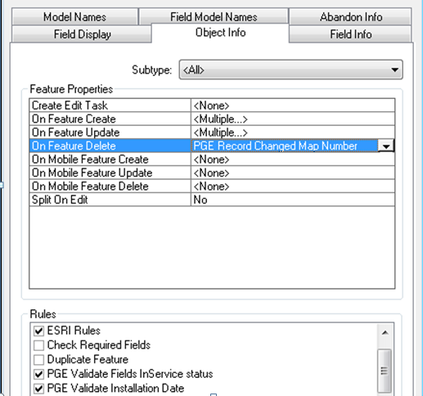
3. Select the checkboxes aboves for the “Rules” portion of the window.
4. Set the below properties for INSTALLATIONDATE.

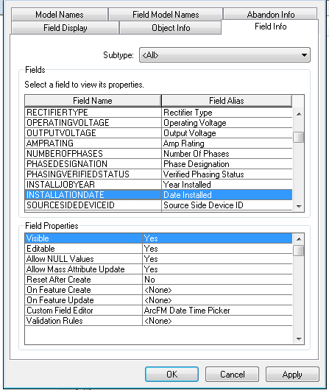

1. Set the below properties for the CREATIONUSER field.

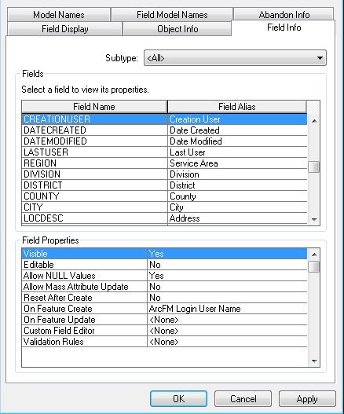

1. Set the below properties for DATECREATED.

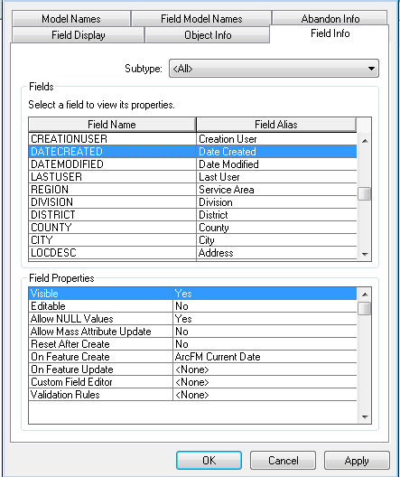

1. Set the below properties for the DATEMODIFIED field.

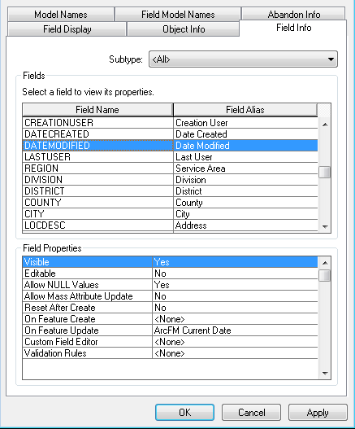

1. Set the below properties for the LASTUSER field.

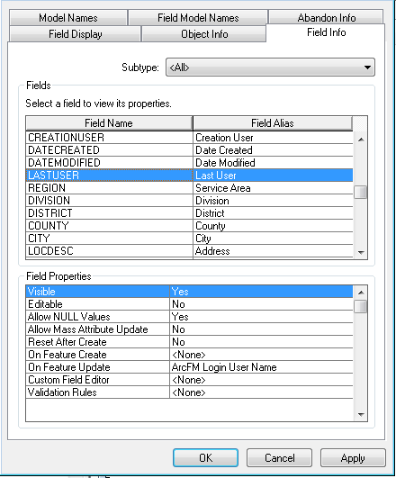

1. Set the below properties for the SYMBOLROTATION field.

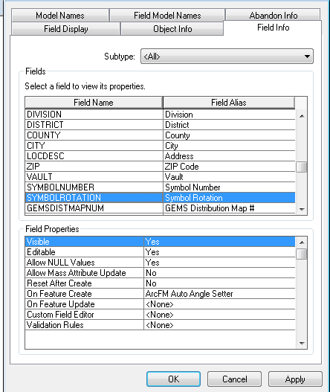

# Set DCConductorInfo Table Attribute Default Values

1. Right click on DCConductorInfo object class and click “Properties”
2. Click on the “Fields” tab and click on the “Conductor Use” row

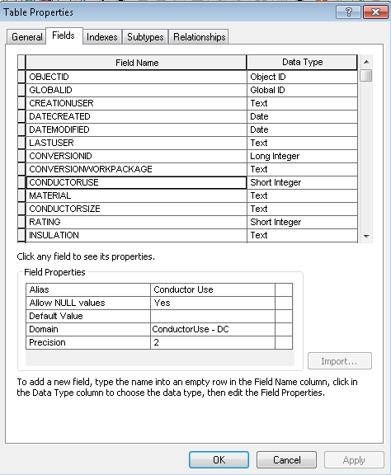

1. Set Default Value = ‘10’

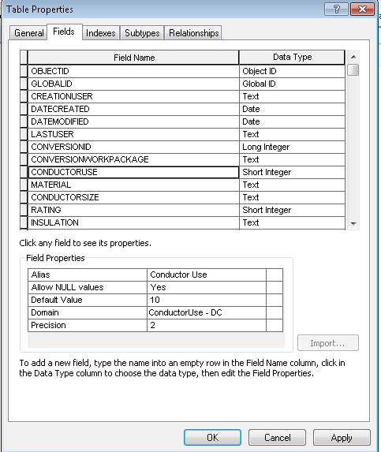

1. Click on the “Material” row

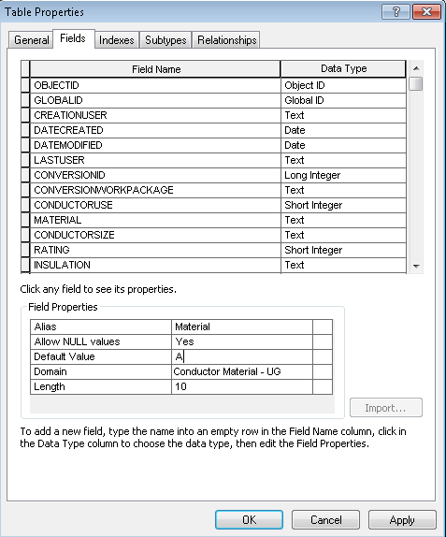

1. Set Default Value = ‘UNK’

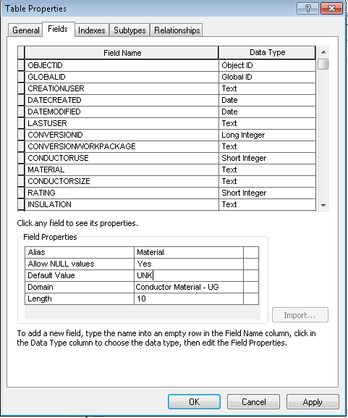

# Set DCRectifier Attribute Value Default

1. Right click on DCRectifier and click “Properties”
2. Click on the subtype tab and locate the “INSTALLATIONTYPE” in the “Default Values and Domains:” section and set the Default Value = ‘UG’

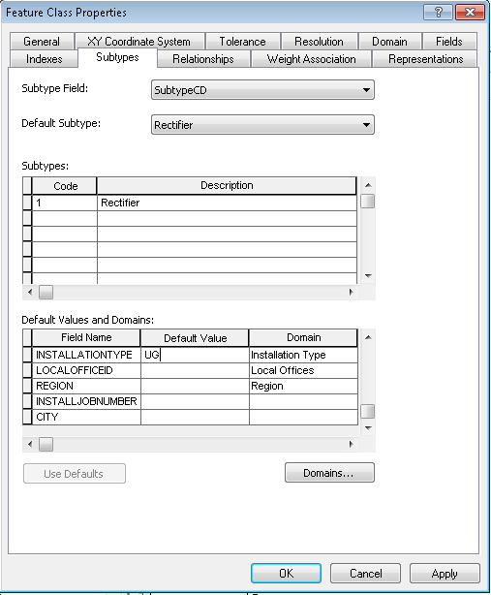

1. Locate the “STATUS” in the “Default Values and Domains:” section and set the Default Value = ‘5’

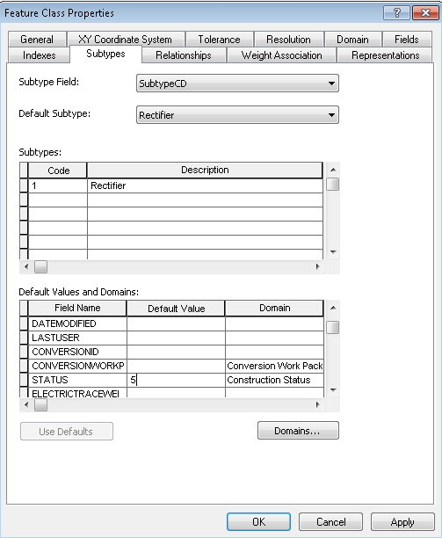

1. Click on the “Fields” tab and locate “Status” in the “Default Values and Domains:” section and set the Default Value = ‘5’

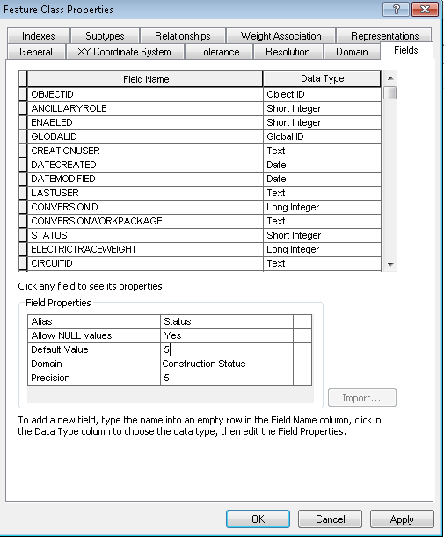

1. Location “Installation Type” and set the Default Value = ‘UG’

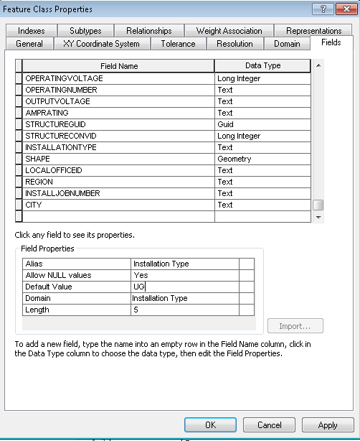

1. Click “OK”

# Add New Field to DCRectifier Feature

1. Right Click on DCRectifier and click “Properties”
2. Click on the “Fields” tab and scroll to the bottom of the current fields

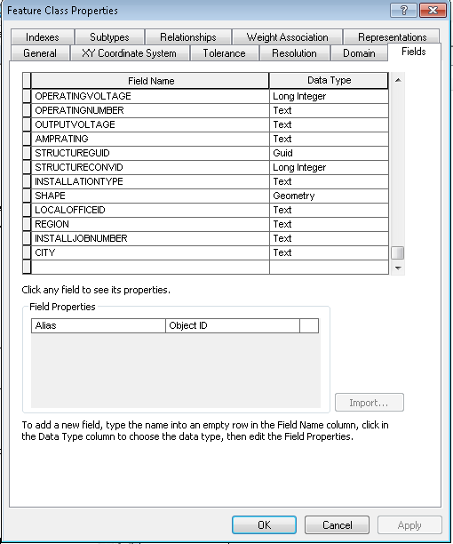

1. Populate as shown below to add RECTIFIERNUMBER

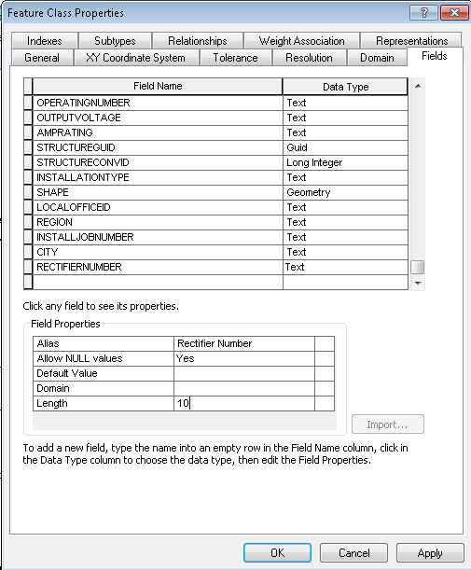

1. Click “OK”

# Add New Annotation SubType/ClassId to DCRectifierAnno

1. Right click on DCRectifierAnno and click “Properties”
2. Click on the “Annotation Classes” tab

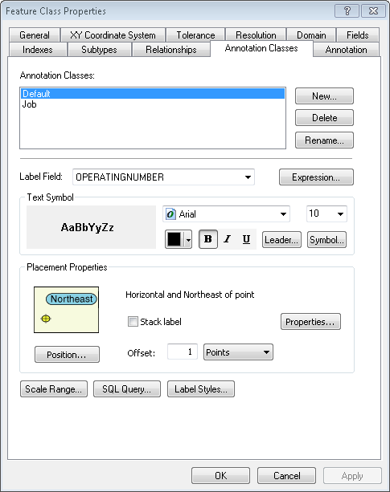

1. Click “New”, populate as shown below and click “OK”

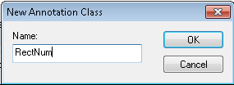

1. Populate as shown below. Unbold, click ‘Apply’, set the size to 8, and click ‘Apply’ **in that order.**
2. Click “Symbol…”

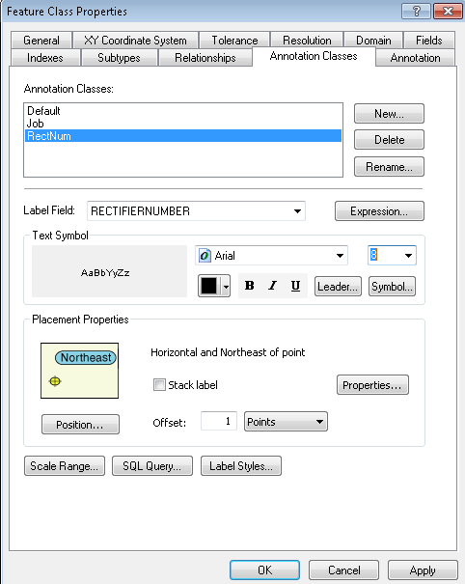

1. Click “Edit Symbol”

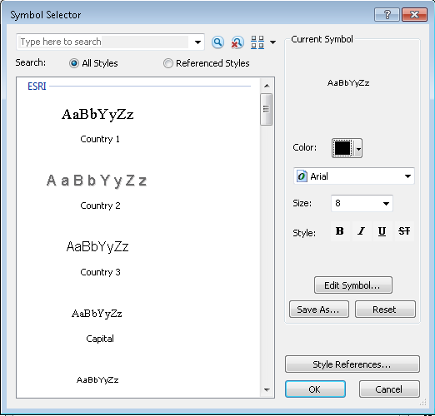

1. Populate as shown below and click “OK” on the “Editor” and “Symbol Selector” dialogs
2. Click “OK” on the “Feature Class Properties” dialog

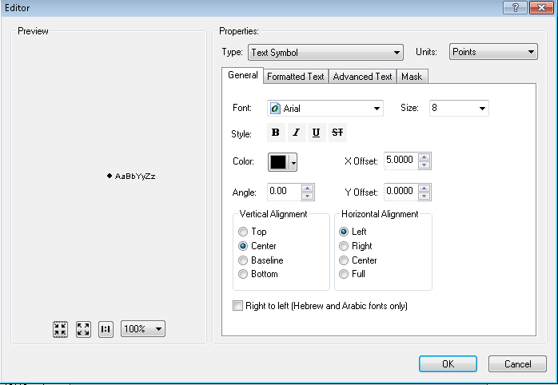

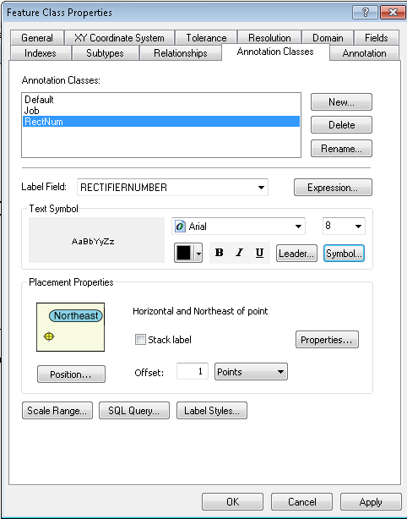

1. Set the Default annotation class’ “Offset” = 7 and change “position” to Offset

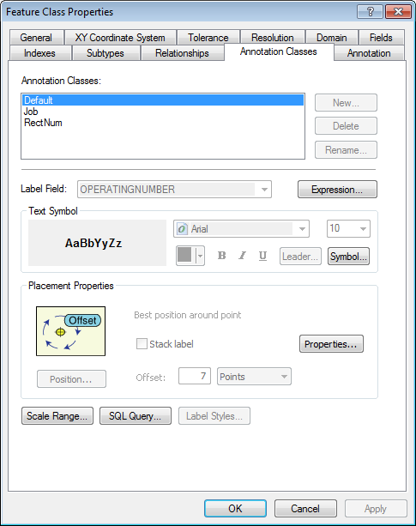

1. For the Job annotation class, set “Offset” = 7 and change “position” to Offset

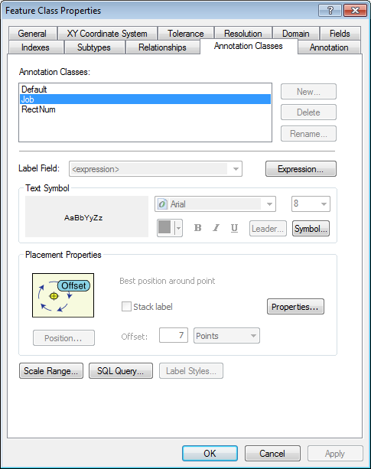

# 1:600 (50ft) Scale Annotation Classes

1. Open ArcCatalog and Navigate to the EDGIS.ElectricDataset

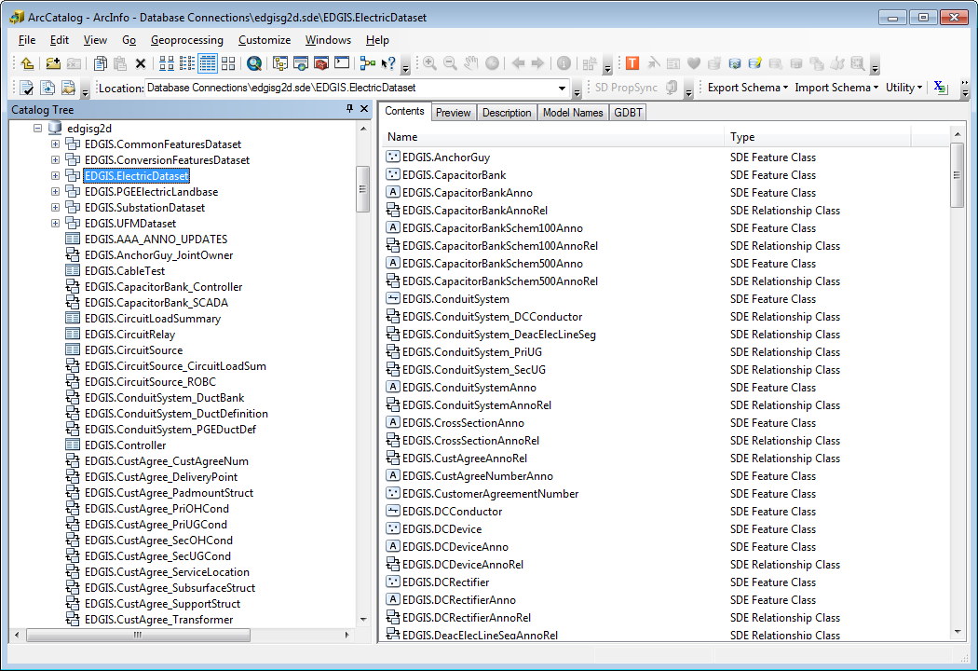

1. Right Click in the “Contents” white space area, click “Import” and “Feature Class (Multiple)”

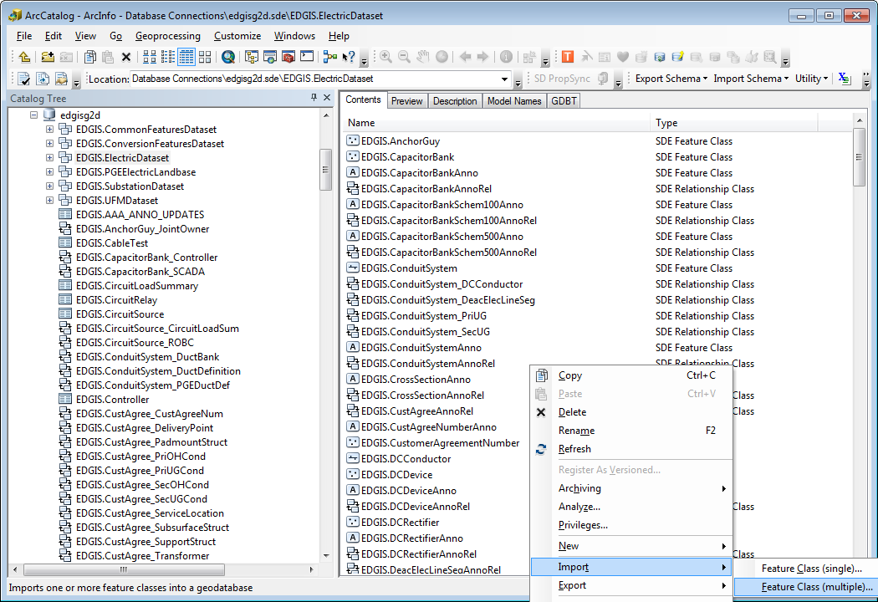

1. Click “Input Features/Database Connections”

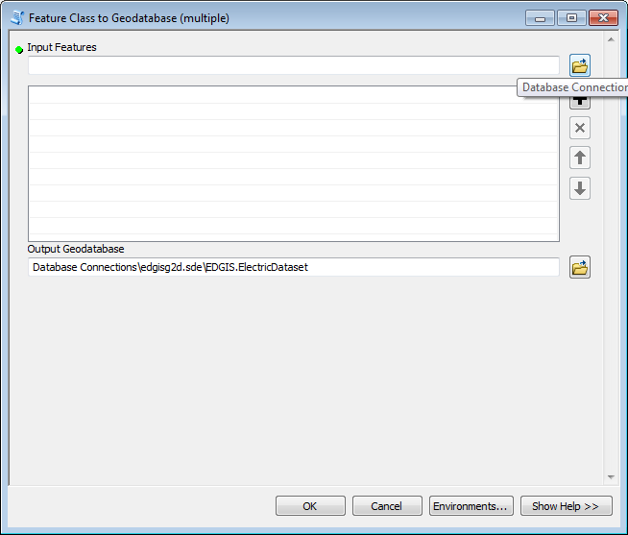

1. Navigate to the “V8-50Scale-Anno.mdb”.

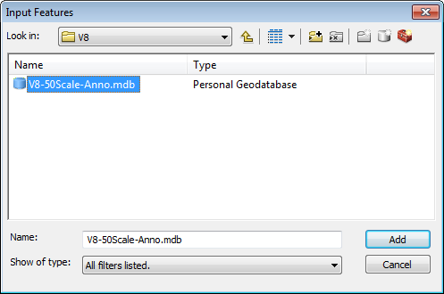

1. Double click on the ElectricDataset

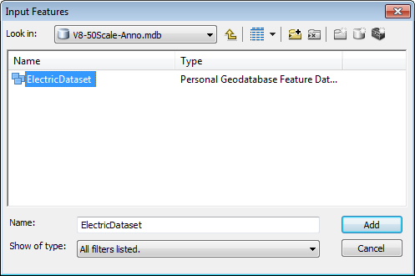

1. Click on “CapacitorBank50Anno”

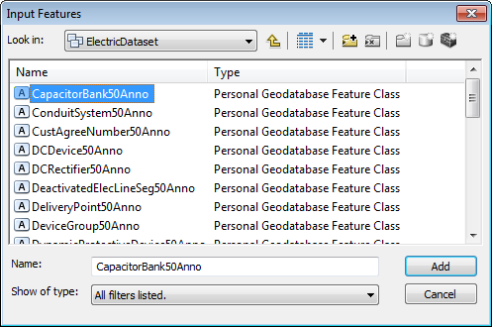

1. Scroll to the bottom of the feature classes and while holding down the *shift* key click on the “VoltageRegulator50Anno” feature class, scroll throughout the list and remove DCDevice and NetworkProtector. All annotation classes should now be selected, click the “Add” button

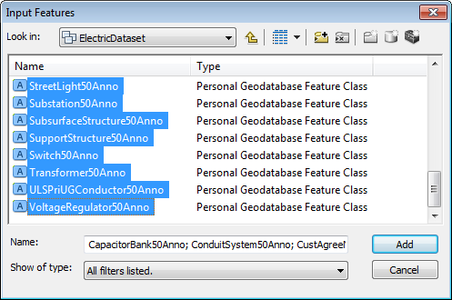

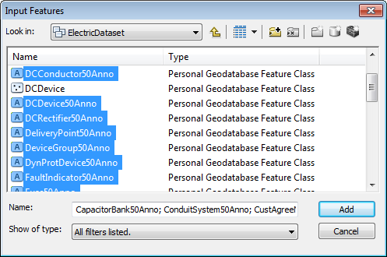

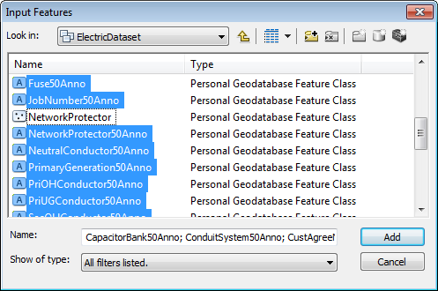

1. Validate the “Output Geodatabase” is ‘<your target database>\EDGIS.ElectricDataset’ and click “OK”

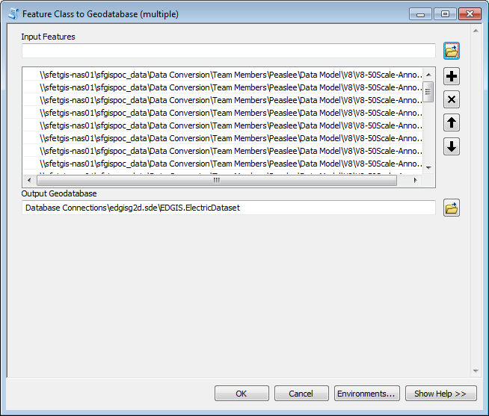

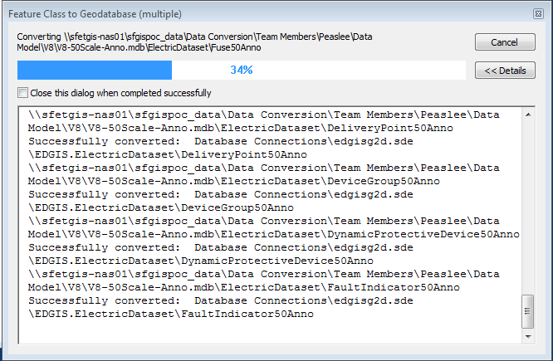

1. Click “Close” after the Import completes.

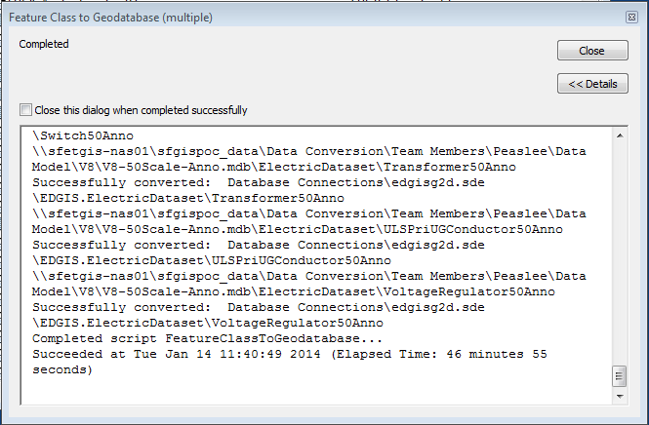

1. Use the below steps to create Relationships between the newly added 50 scale annotation to their respective feature classes based on the below chart.
2. In the Contents tab of the right hand side panel, select New->Relationship Class.

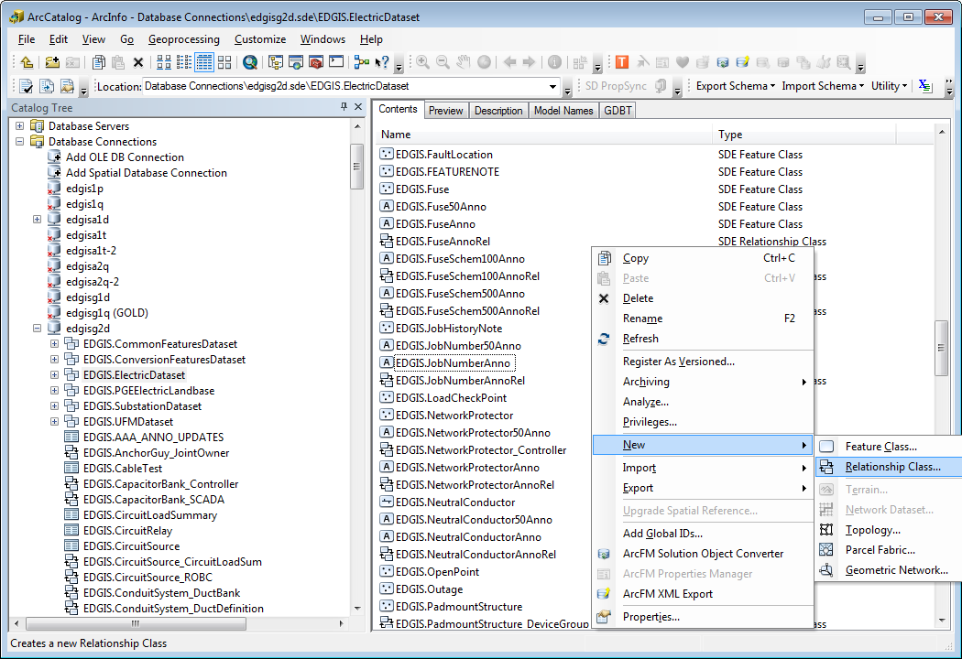

1. Populate “Name of the relationship class:” with ‘Relationship Name’ shown in column 3 of the table below, “Origin table/feature class:” with ‘Related Feature Class’ shown in column 2 of the table below and “Destination table/feature class:” with ‘Annotation’ shown in column 1 of the table below.

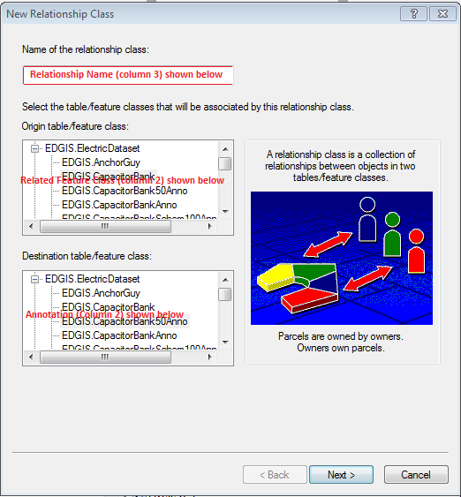

1. Change to “Composite” relationship type and click “Next”

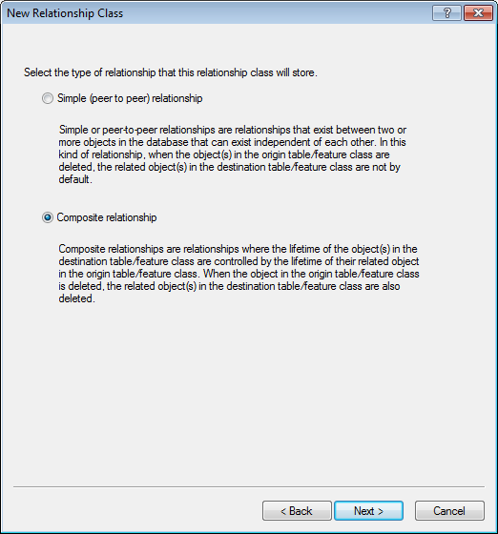

1. Leave as-is unless noted in columns 4 and 5 in the table below and click “Next”

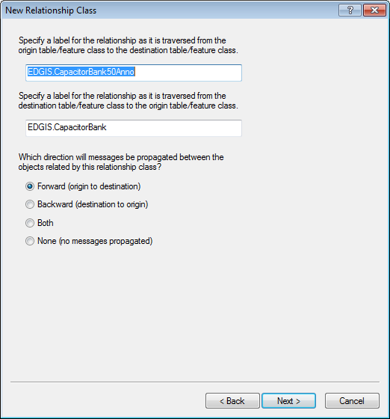

1. Validate setting is 1-M and click “Next”

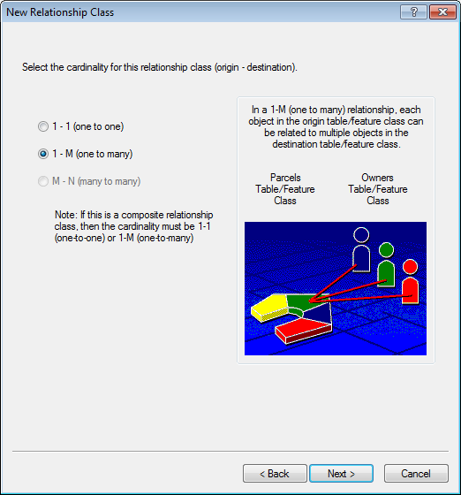

1. Leave as-is and click “Next”

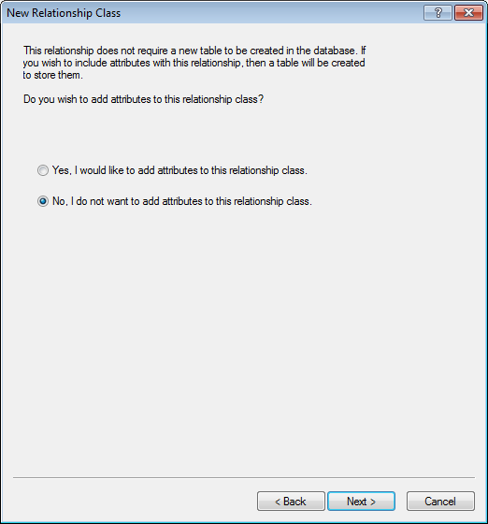

1. Populate as shown below and click “Next”

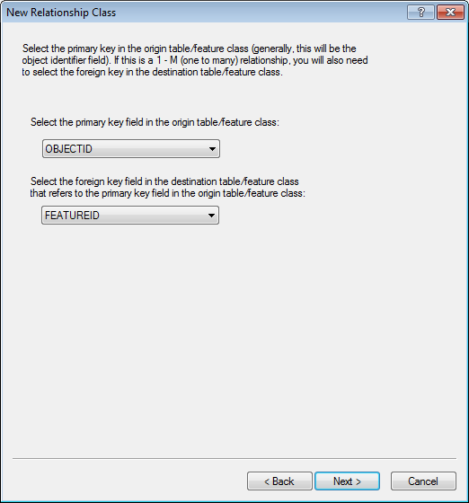

1. Click “Finish”

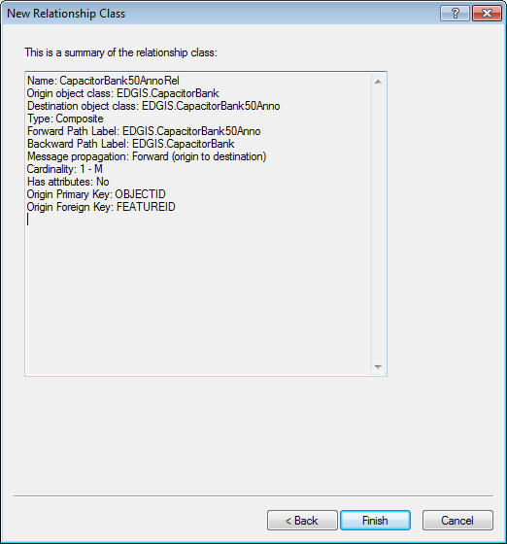

1. 50 Scale Annotation Feature class relationship creation.

|  |  |  |  |  |
| --- | --- | --- | --- | --- |
| Annotation | Related Feature Class | Relationship Name | Origin table/feature class Label (outside of default) | Origin table/feature class Label (outside of default) |
| CapacitorBank50Anno | CapacitorBank | CapacitorBank50AnnoRel |  |  |
| ConduitSystem50Anno | ConduitSystem | ConduitSystem50AnnoRel |  |  |
| CustAgreeNumber50Anno | CustomerAgreementNumber | CustAgreeNumber50AnnoRel |  |  |
| DCConductor50Anno | DCConductor | DCConductor50AnnoRel |  |  |
| DCDevice50Anno | DCDevice | DCDevice50AnnoRel |  |  |
| DCRectifier50Anno | DCRectifier | DCRectifier50AnnoRel |  |  |
| DeactivatedElecLineSeg50Anno | DeactivatedElectricLineSegment | DeactivatedElecLineSeg50AnnoRel | EDGIS.DeactElecLineSeg50Anno | EDGIS.DeactElectricLineSegment |
| DeliveryPoint50Anno | DeliveryPoint | DeliveryPoint50AnnoRel |  |  |
| DeviceGroup50Anno | DeviceGroup | DeviceGroup50AnnoRel |  |  |
| DynProtDevice50Anno | DynamicProtectiveDevice | DynProtDevice50AnnoRel |  |  |
| FaultIndicator50Anno | FaultIndicator | FaultIndicator50AnnoRel |  |  |
| Fuse50Anno | Fuse | Fuse50AnnoRel |  |  |
| JobNumber50Anno | JobHistoryNote | JobNumber50AnnoRel |  |  |
| NetworkProtector50Anno | NetworkProtector | NetworkProtector50AnnoRel |  |  |
| NeutralConductor50Anno | NeutralConductor | NeutralConductor50AnnoRel |  |  |
| PrimaryGeneration50Anno | PrimaryGeneration | PrimaryGeneration50AnnoRel |  |  |
| PriOHConductor50Anno | PriOHConductor | PriOHConductor50AnnoRel |  |  |
| PriUGConductor50Anno | PriUGConductor | PriUGConductor50AnnoRel |  |  |
| SecOHConductor50Anno | SecOHConductor | SecOHConductor50AnnoRel |  |  |
| SecondaryGeneration50Anno | SecondaryGeneration | SecondaryGeneration50AnnoRel |  |  |
| SecUGConductor50Anno | SecUGConductor | SecUGConductor50AnnoRel |  |  |
| StepDown50Anno | StepDown | StepDown50AnnoRel |  |  |
| StreetLight50Anno | StreetLight | StreetLight50AnnoRel |  |  |
| Substation50Anno | Substation | Substation50AnnoRel |  |  |
| SubsurfaceStructure50Anno | SubsurfaceStructure | SubsurfaceStructure50AnnoRel |  |  |
| SupportStructure50Anno | SupportStructure | SupportStructure50AnnoRel |  |  |
| Switch50Anno | Switch | Switch50AnnoRel |  |  |
| Transformer50Anno | Transformer | Transformer50AnnoRel |  |  |
| VoltageRegulator50Anno | VoltageRegulator | VoltageRegulator50AnnoRel |  |  |

# Rebuild Geometric Networks

1. Follow the steps contained in the below documents to rebuild the geometric networks, using the provided connectivity XML in the folder from Section 1.3:  
   
2. The DCConductor and DCRectifier where removed from the network in the above steps, these need to be removed from the geometric network XML. Open the XML in an XML editor and search for DCConductor and DCRectifier and remove these sections.

A couple of examples of what to removed:

<featureClass database="" owner="EDGIS" table="DCConductor" esriFeatureType="10" esriNetworkClassAncillaryRole=""/>

<edge database="" owner="EDGIS" table="DCConductor">

<subtype name="DC Conductor">

<junction database="" owner="EDGIS" table="DCRectifier">

<subtype name="Rectifier" eMin="0" eMax="3" jMin="0" jMax="1" default="False"/>

</junction>

<junction database="" owner="EDGIS" table="ElectricDistNetwork_Junctions">

<subtype name="" eMin="-1" eMax="-1" jMin="-1" jMax="-1" default="False"/>

</junction>

<junction database="" owner="EDGIS" table="ElectricStitchPoint">

<subtype name="Source" eMin="0" eMax="1" jMin="0" jMax="1" default="False"/>

</junction>

<junction database="" owner="EDGIS" table="ElectricStitchPoint">

<subtype name="Load" eMin="0" eMax="1" jMin="0" jMax="1" default="False"/>

</junction>

<junction database="" owner="EDGIS" table="OpenPoint">

<subtype name="Open Point" eMin="0" eMax="2" jMin="0" jMax="1" default="False"/>

</junction>

</subtype>

</edge>

1. Use GDB Designer to load the connectivity rules, using the file created above

# ArcFMify ElectricDataset

1. Make a <fake> version using the edgis user. Right click on the database and click “Versions…”

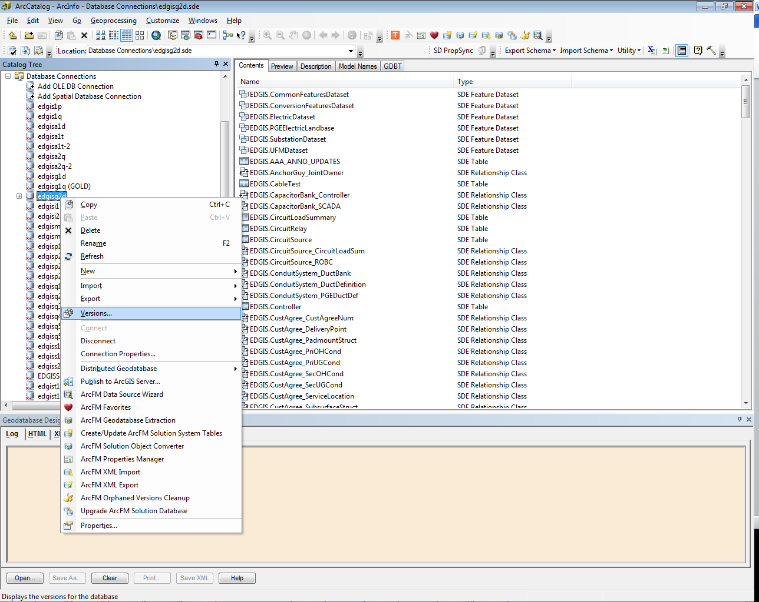

1. Right click on “Default” and click “New…”

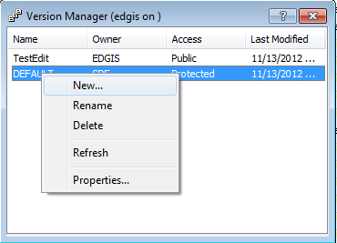

1. Populate as shown below (version name may be anything you choose but make it something intuitive to the task) and click “OK”

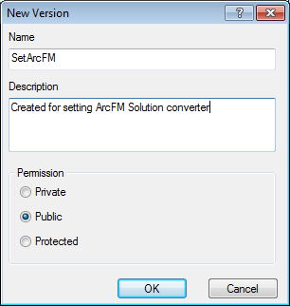

1. Click “X” on Version Manager dialog to close
2. Change Connection settings, right click on the database and click “Connection Properties…”

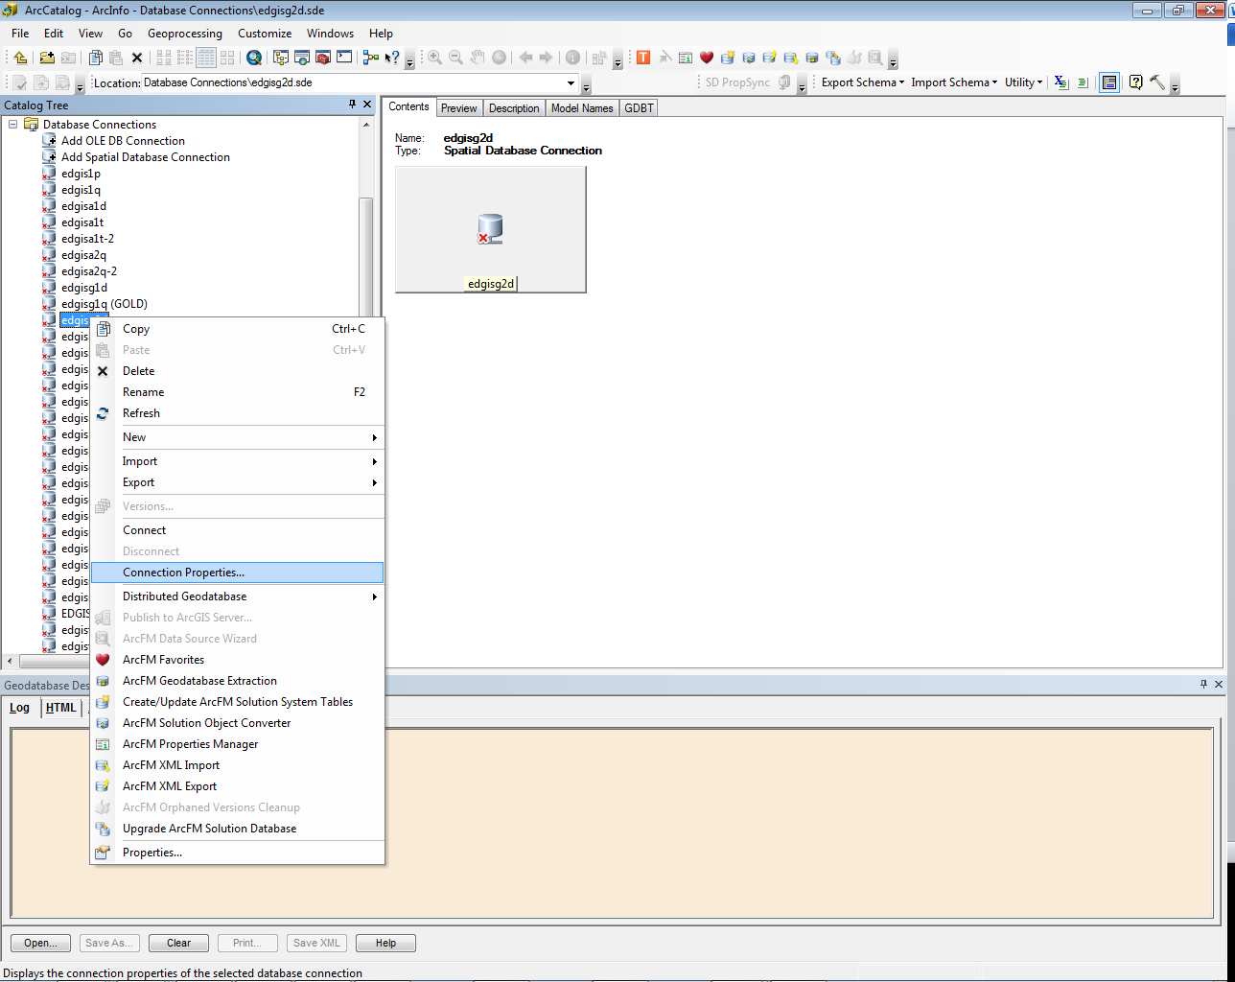

1. Set login credentials and click “Change…” in the “Connection details”

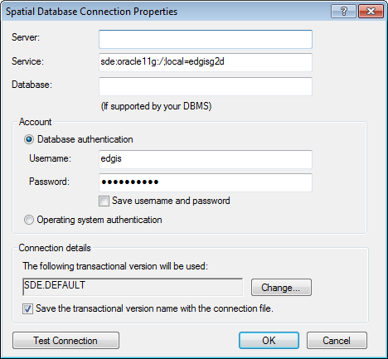

1. Select the version created in step #3 and click “OK”

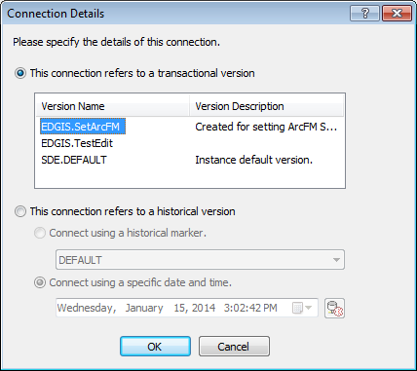

1. Click “OK”

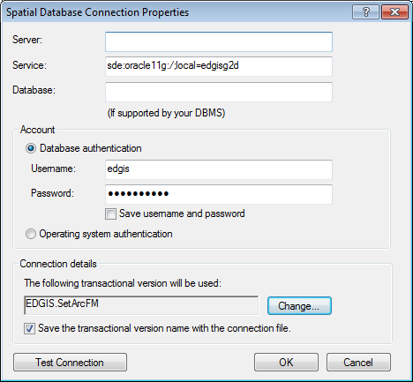

1. Set login credentials and click “OK”

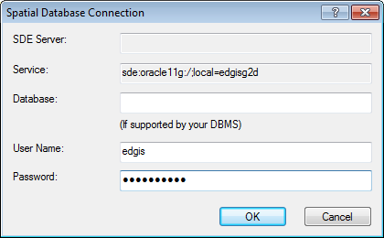

1. Right click on the ElectricDataset and click “ArcFM Solution Object Converter”

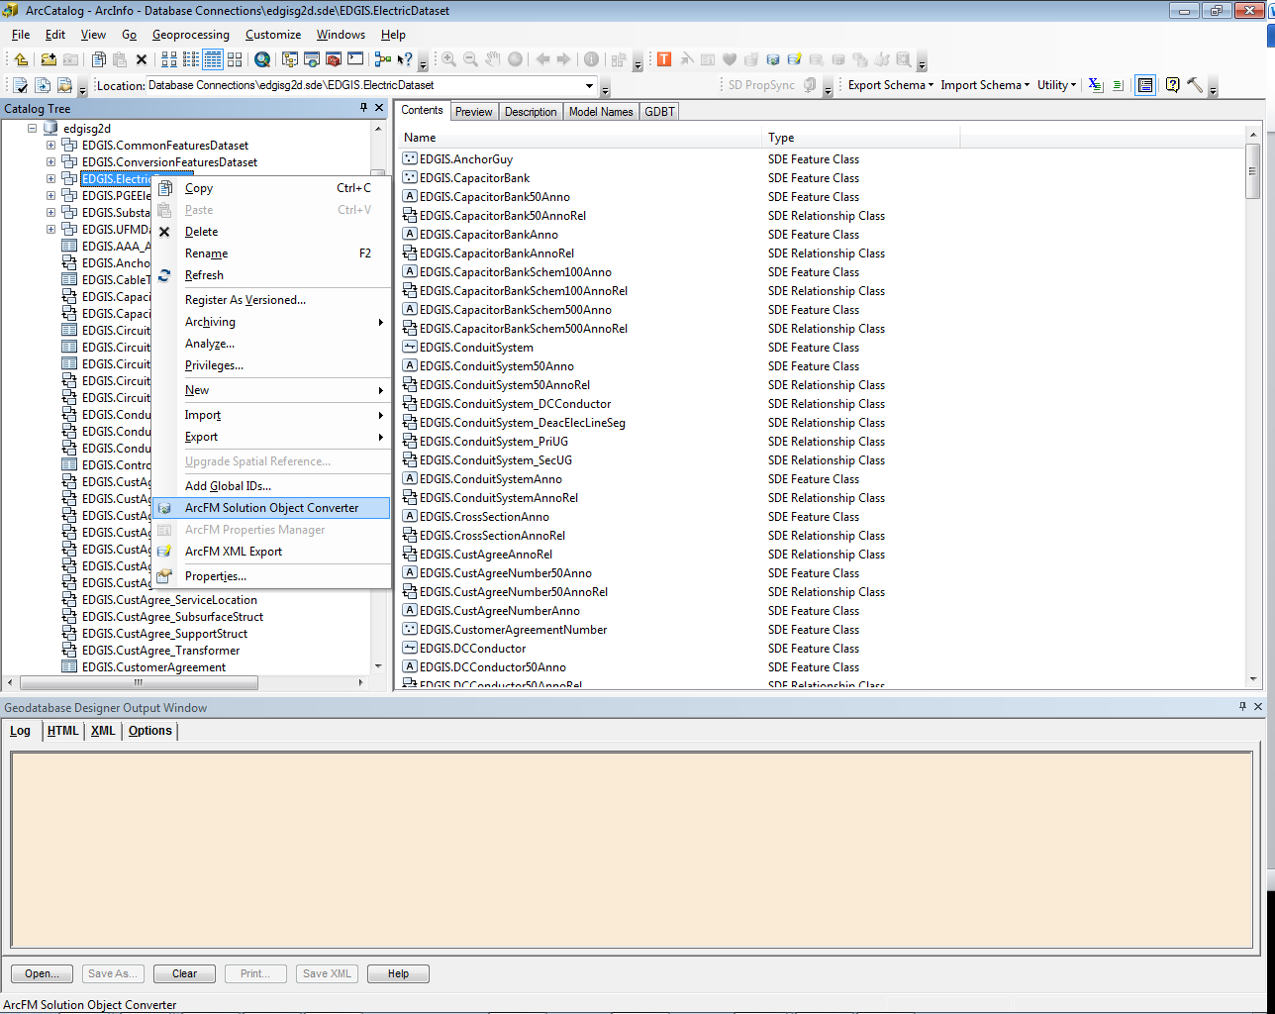

1. Click “OK”

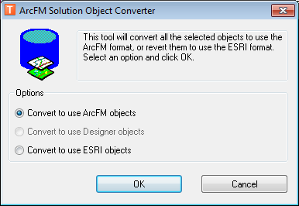

12. Click “YES”

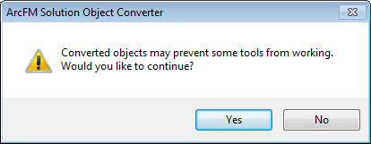

1. Click “OK”

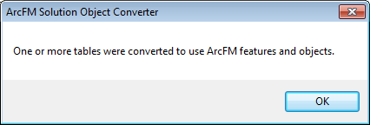

1. Perform the above steps for the SubstationDataset also.
2. Make sure to set your connection back to SDE.DEFAULT using the same steps 5-9 but change to version to “SDE.DEFAULT”

# Insert GlobalIDs into all new feature classes

1. Add GlobalID by right clicking the EDGIS.ElectricDataset and clicking “Add Global IDs…”
2. Click “Yes”

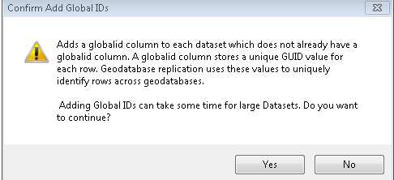

1. Observe GLOBALID has been added to the following feature classes:
   1. DCDevice
   2. DCDeviceAnno
   3. Network Protector
2. Repeat steps 1-2 using the UFMDataset.
3. Observe GLOBALID has been added to the following feature class:
   1. Dimension
4. Repeat steps 1-2 using the SubstationDataset.
5. Observe GLOBALID has been added to the following feature class:
   1. SUBLinkAnno

# Assign ArcFM Properties

1. Assign the following Field Model Name to the NetworkProtector feature class.

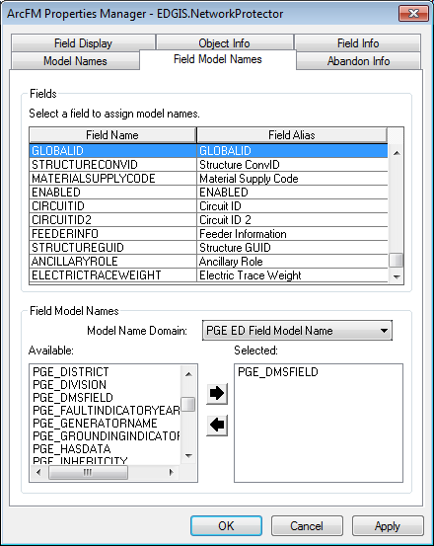

1. Assign the following autoupdaters to the NetworkProtector feature class On Feature Create  
   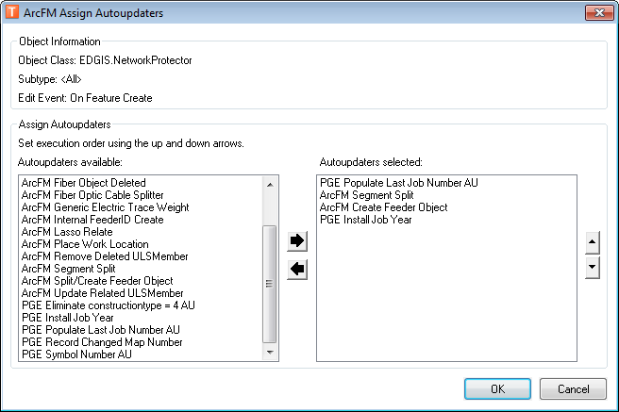
2. Assign the following autoupdaters to the NetworkProtector feature class On Feature Update

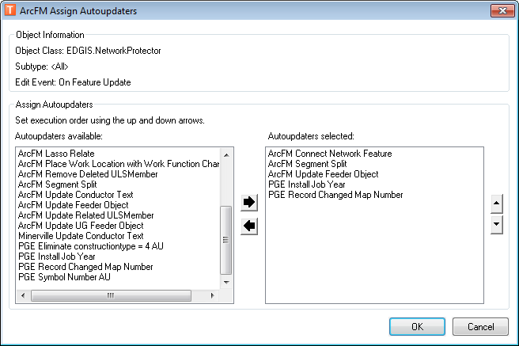

1. Assign the following autoupdaters to the NetworkProtector feature class On Feature Delete

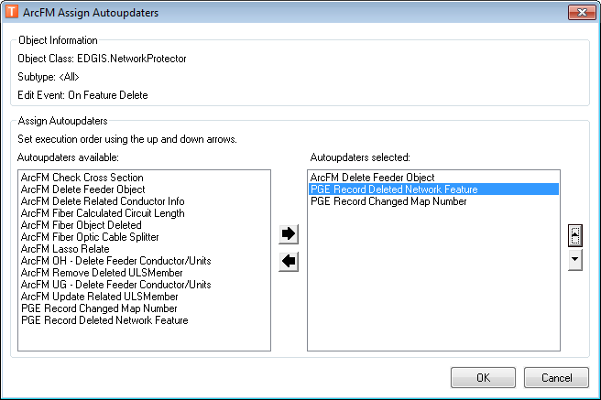

## Remove Feeder Manager AUs from DC Rectifier

1. In the Object Info tab, set “On Feature Create” AUs to match what is shown below

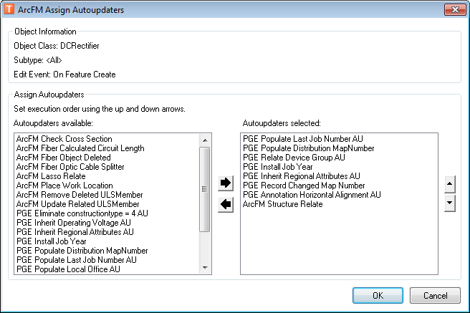

1. Set “On Feature Update” AUs to match what is shown below

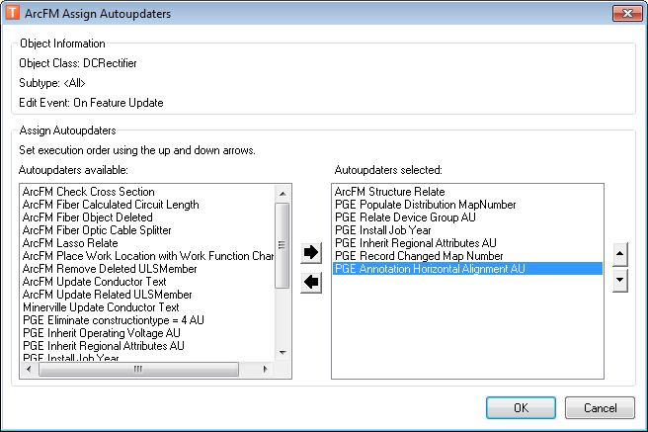

1. Set “On Feature Delete” AUs to match what is shown below

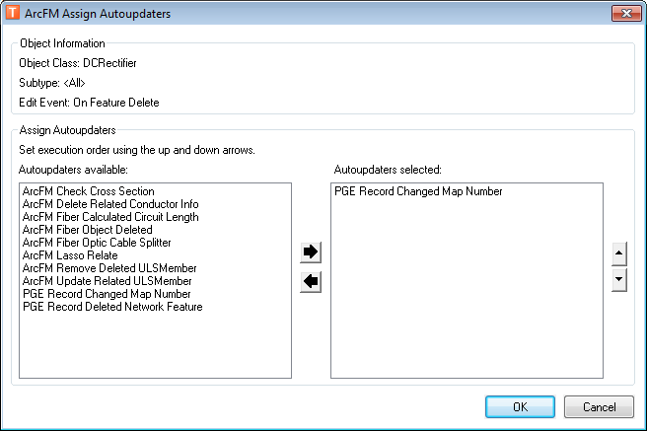

## Remove Feeder Manager AUs from DC Conductor

1. Set “On Feature Create” AUs to match what is shown below

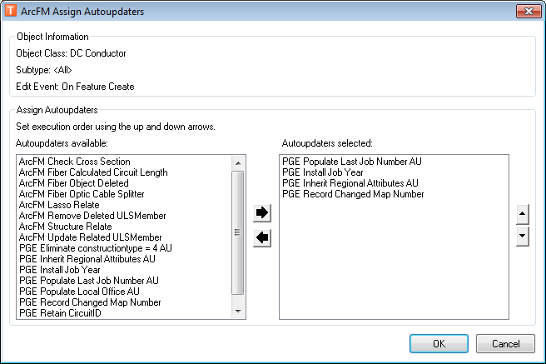

1. Set “On Feature Update” AUs to match what is shown below

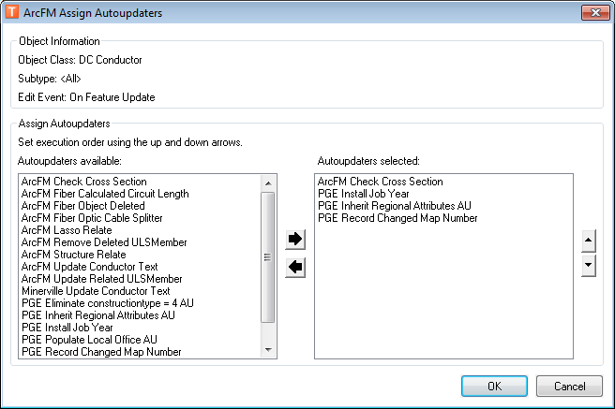

1. Set “On Feature Delete” AUs to match what is shown below

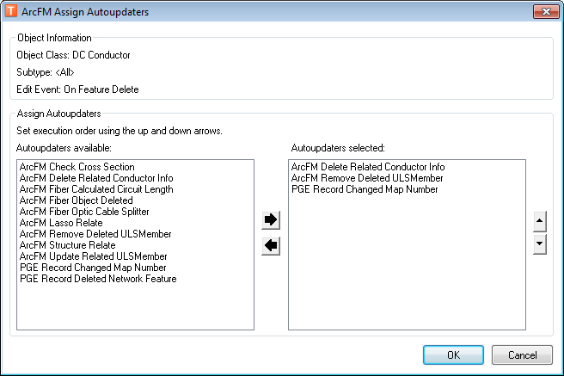

## Remove AUs From FaultIndicator

1. In the ElectricDataset, right click FaultIndicator and select ArcFM Properties Manager.
2. Select the Object Info tab, click the dropdown next to On Feature Create, and click <Multiple…>.  
   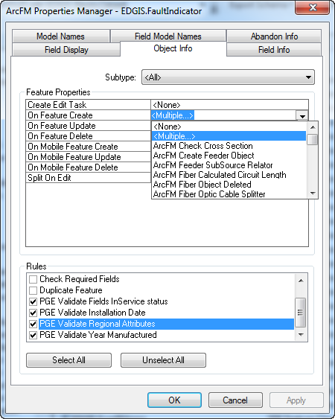
3. Double click the Symbol Number AU on the right hand side box to remove it from the feature class.  
   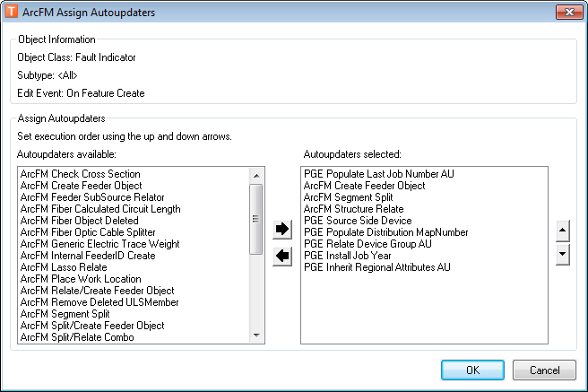
4. Click OK.
5. Repeat steps 2-4 for On Feature Update also.

# Create Relationships

## Create relationship for NetworkProtector, Transformer

1. In the ElectricDataset, right click the empty area in the Contents tab of the right hand side panel, and select New->Relationship Class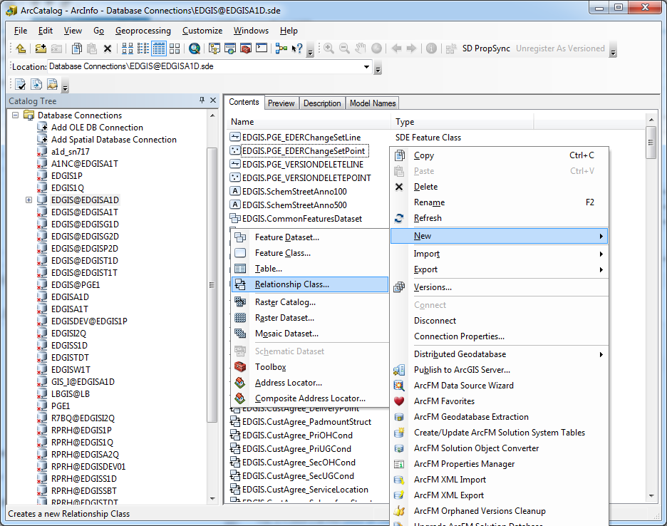
2. Fill out the screens as follows:  
   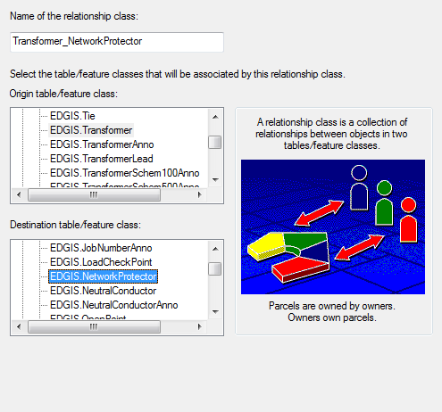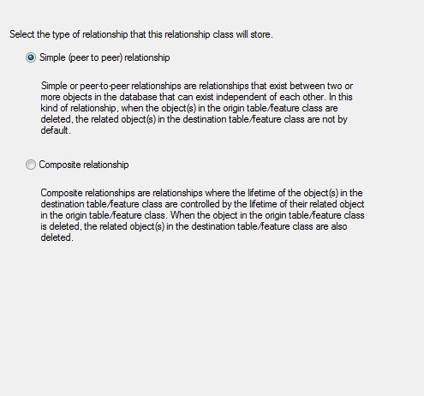  
   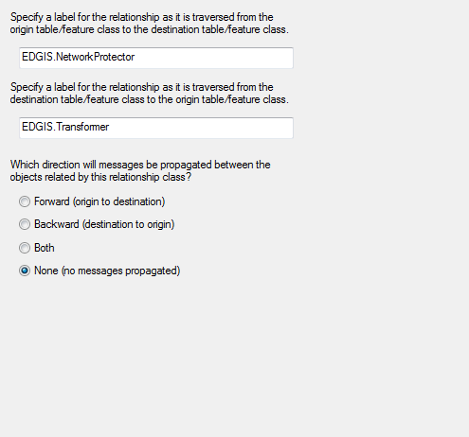  
   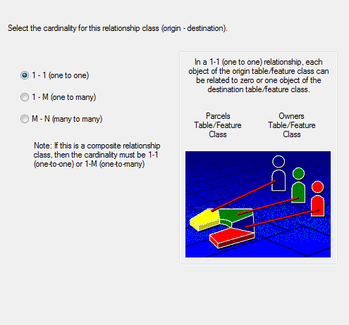  
   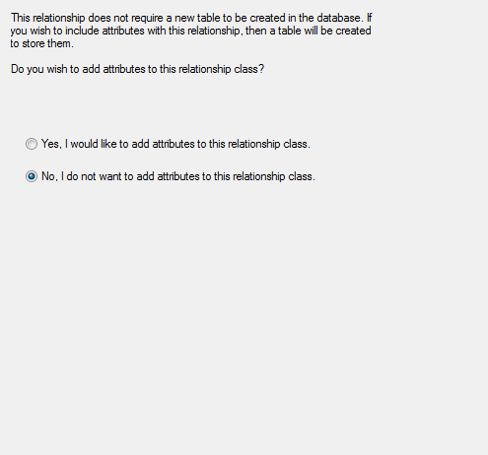  
   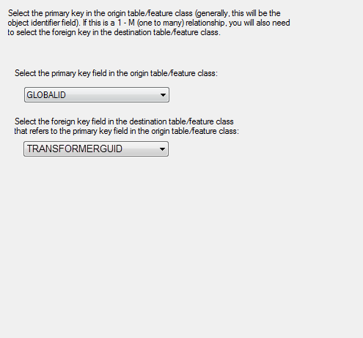

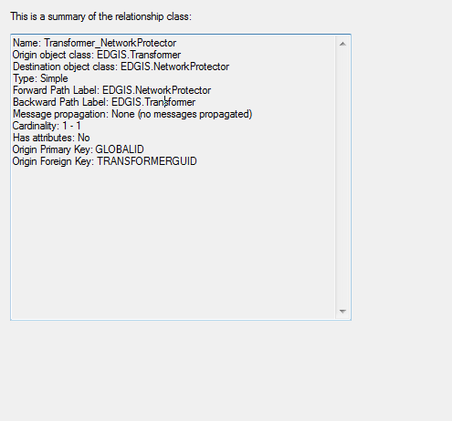

## Create relationship for NetworkProtector, Controller

1. At the root level, right click in ArcCatalog’s Content window, click “New->Relationship…” class
2. Populate as shown below and click “Next”

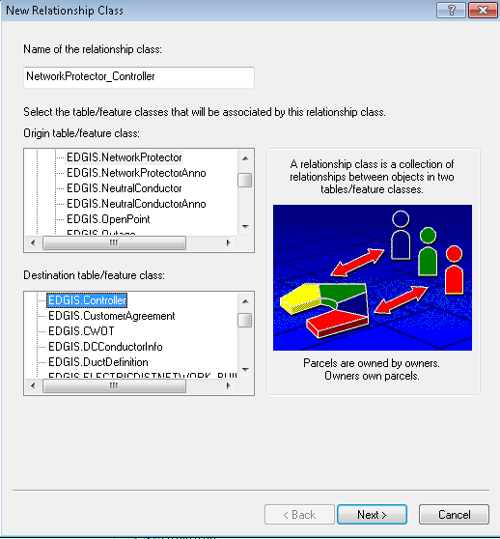

1. Click “Next”

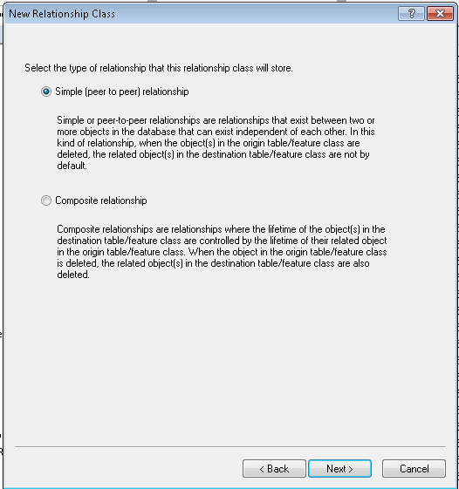

1. Click “Next”

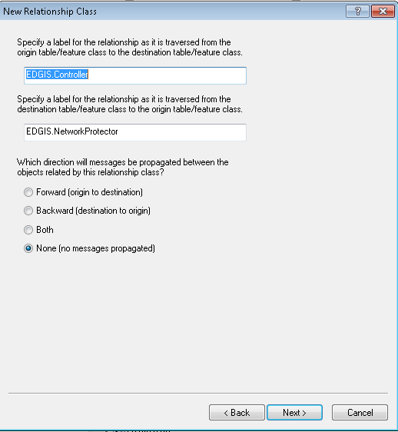

1. Populate as shown below and click “Next”

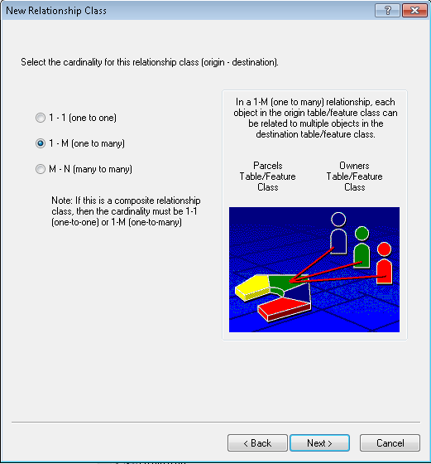

1. Click “Next”

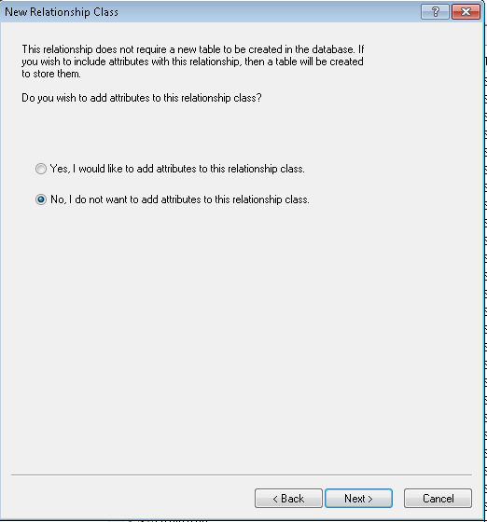

1. Populate as shown below and click “Next”

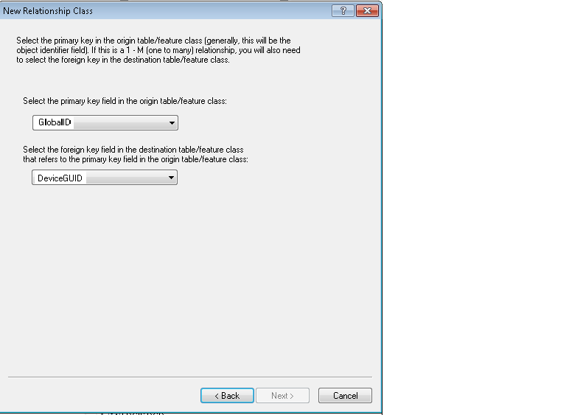

1. Click “Finish”

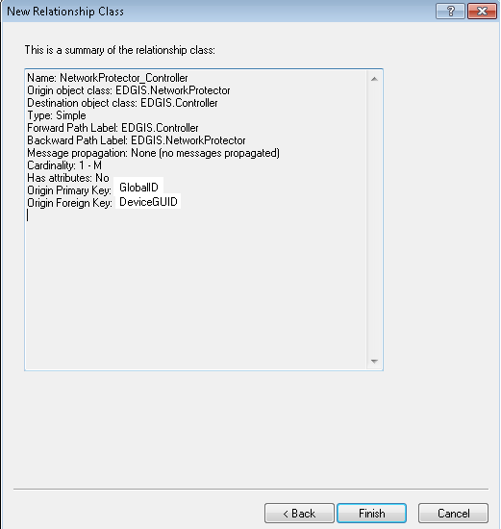

## Create Relationship for Switch, Transformer

1. In the ElectricDataset, right click the empty space in the Contents tab on the right hand side box of ArcCatalog and select New->Relationship Class  
   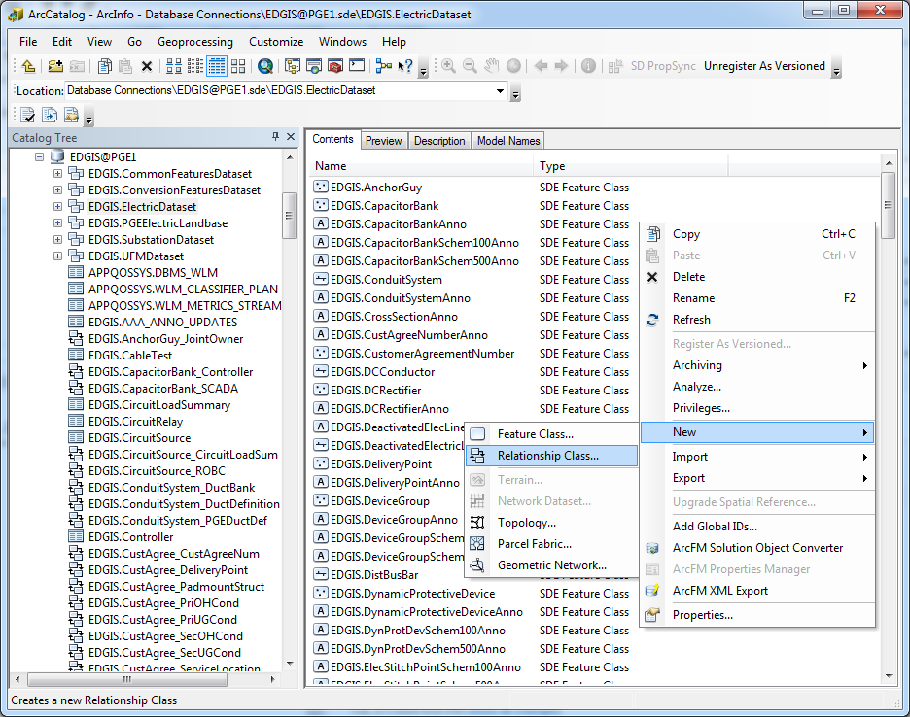
2. Fill in the subsequent screens as below to create the relationship class:  
   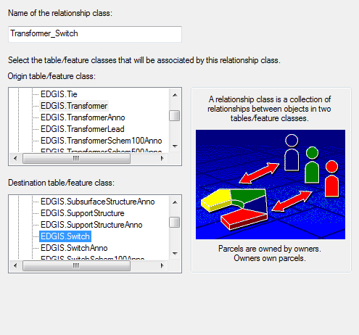



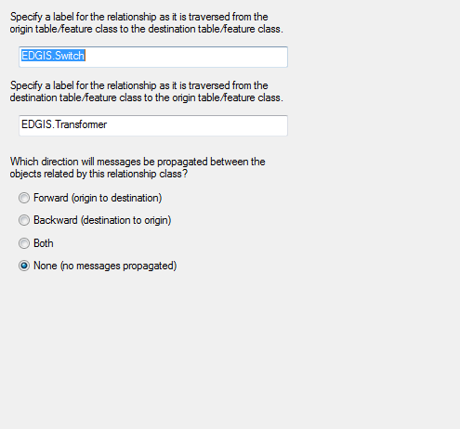



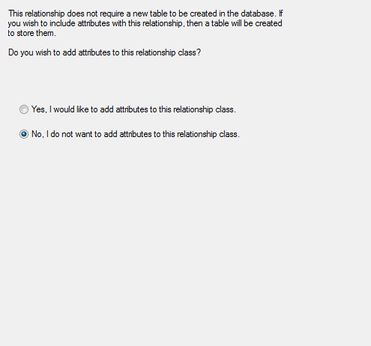

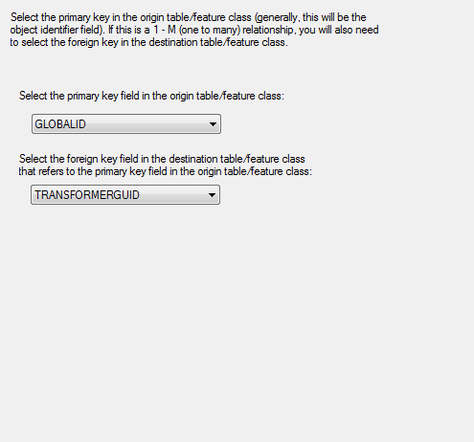

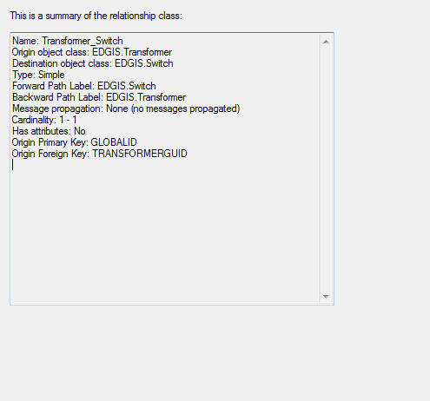

# Create 50 Scale Annotation Views

1. Log into Sqlplus as the EDGIS user and copy/paste the text of the PGE_CREATE_VIEWS.sql script found in the location referenced in Section 1.3.
2. Copy/paste the resulting output into a log file named “CREATE_VIEWS_OUTPUT.log” and save into the same folder in which the script is located.

# Update Data Model Version Table

**Database Configuration:**

1. Open SQL Plus.
2. Log in using the same server and user as was used in section 2.  
     
   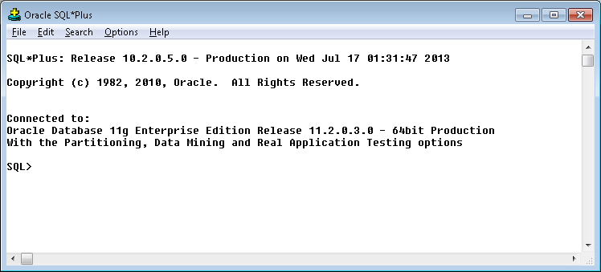
3. Run the SQL below:

update pgedatamodelversion set currentidc='N' where currentidc='Y';

insert into pgedatamodelversion (OBJECTID, CURRENTIDC, DATEAPPLIED, APPLIEDBYPERSONNAME, MODELVERSION) values (**50**,'Y',sysdate,'**<INSERT TEAM MEMBER DONE BY>**','**8.0** GOLD **CR11098**');

commit;

# Known Issues

<Please List any other issues encountered here while following the document>